**1. Data structure 1_Arrays_Chapter 1**

TASK1:

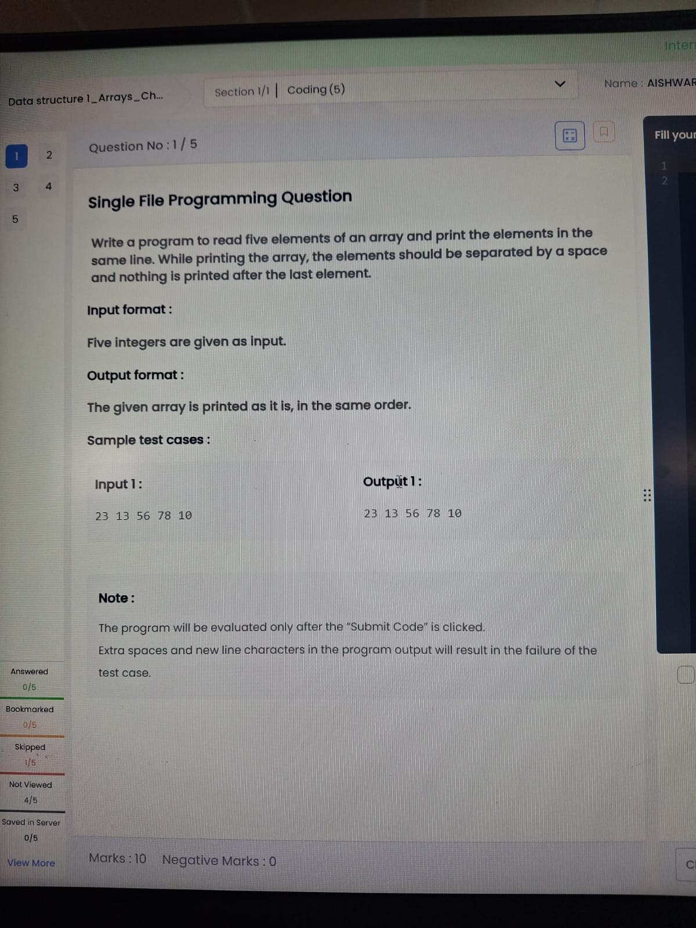

import java.util.*;

public class Main {

public static void main(String[] args) {

Scanner sc = new Scanner(System.in);

int[] a = new int[5];

for(int i=0;i<5;i++)

a[i] = sc.nextInt();

for(int i=0;i<5;i++){

System.out.print(a[i]);

if(i<4) System.out.print(" ");

}

}

}

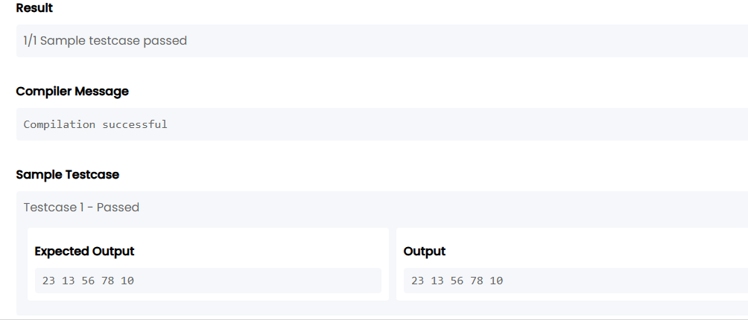

TASK2:

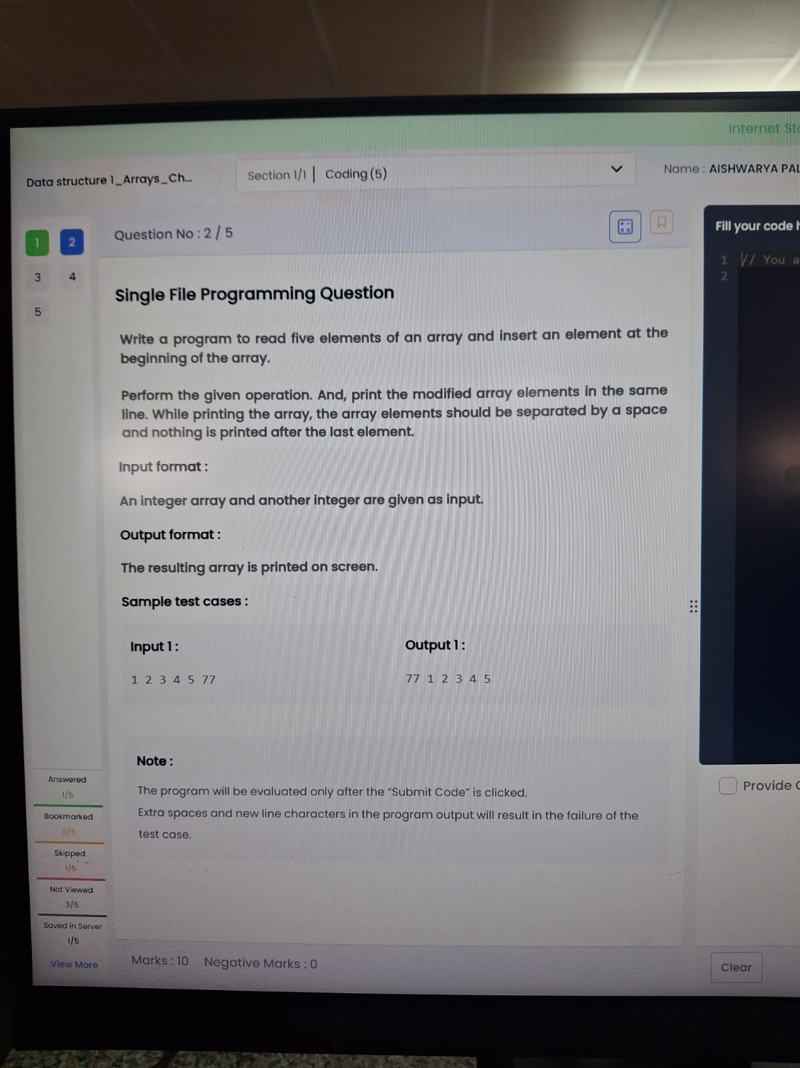

import java.util.*;

public class Main {

public static void main(String[] args) {

Scanner sc = new Scanner(System.in);

int[] a = new int[5];

for(int i=0;i<5;i++)

a[i] = sc.nextInt();

int x = sc.nextInt();

System.out.print(x + " ");

for(int i=0;i<5;i++){

System.out.print(a[i]);

if(i<4) System.out.print(" ");

}

}

}

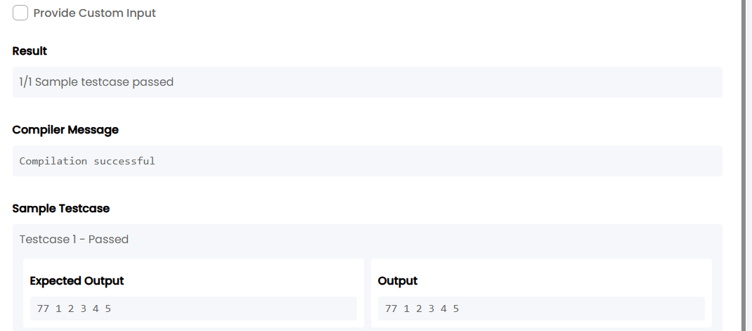

TASK3:

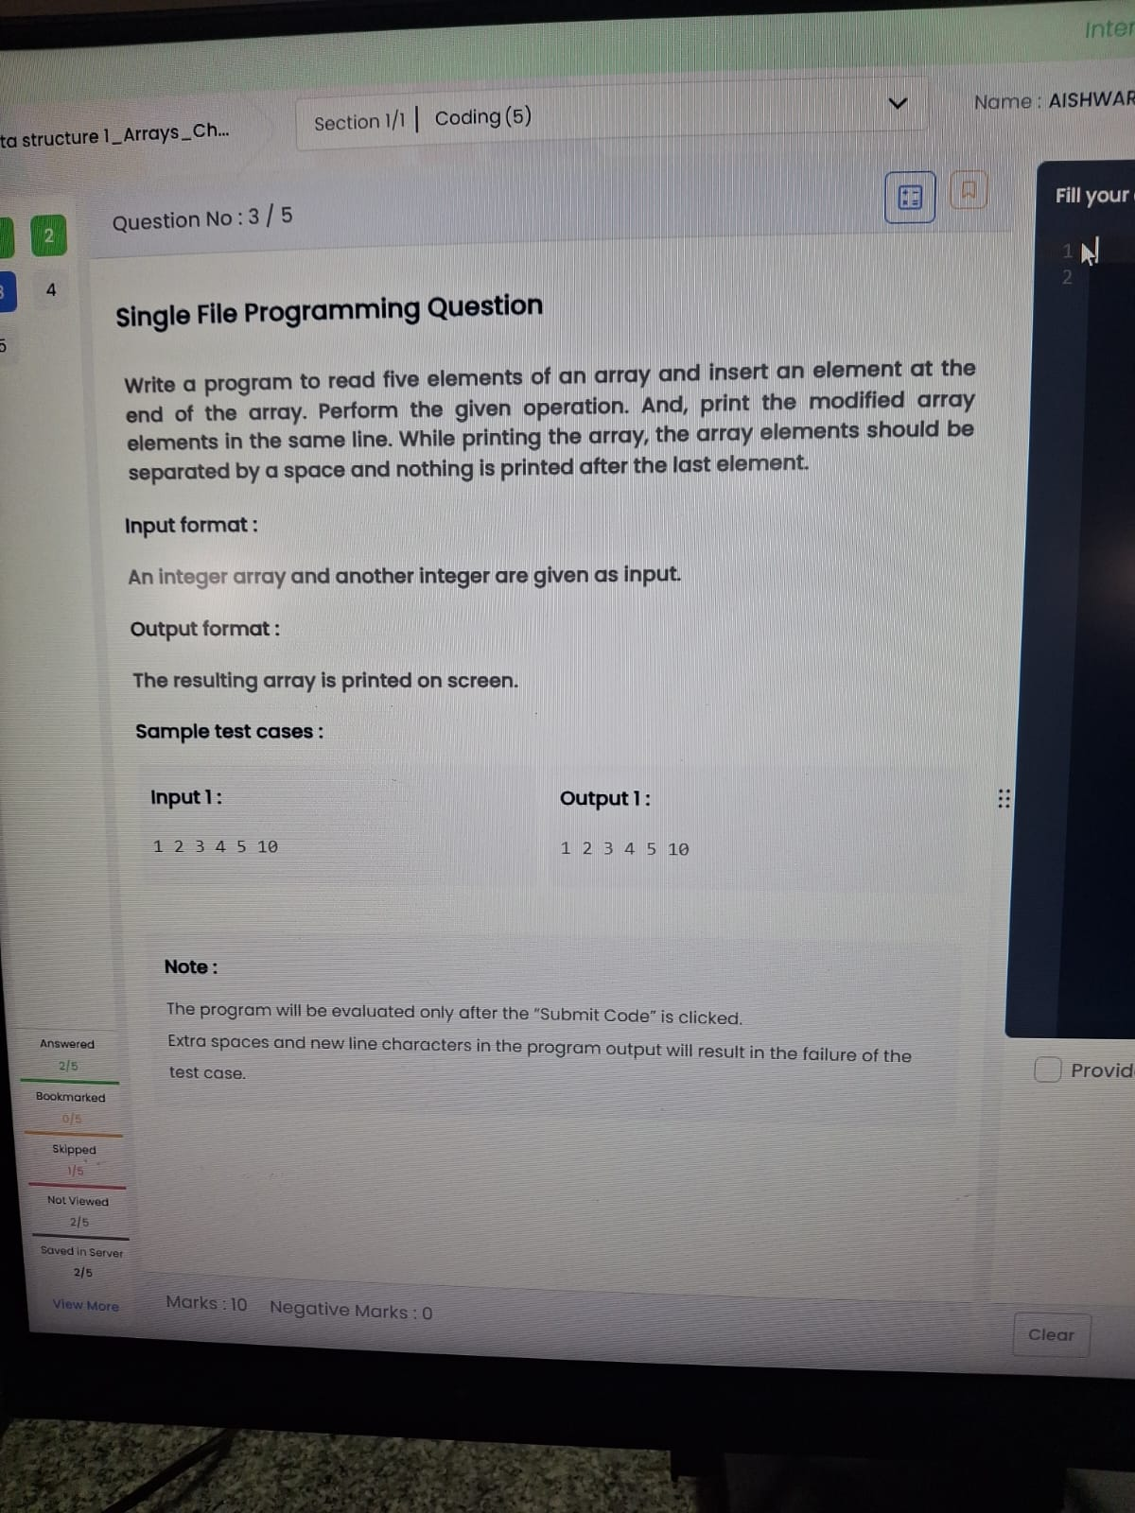

import java.util.*;

public class Main {

public static void main(String[] args) {

Scanner sc = new Scanner(System.in);

int[] a = new int[6];

for(int i=0;i<5;i++)

a[i] = sc.nextInt();

a[5] = sc.nextInt();

for(int i=0;i<6;i++){

System.out.print(a[i]);

if(i<5) System.out.print(" ");

}

}

}

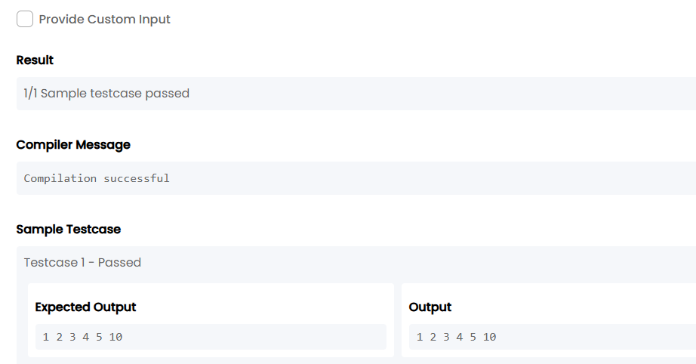

TASK4:

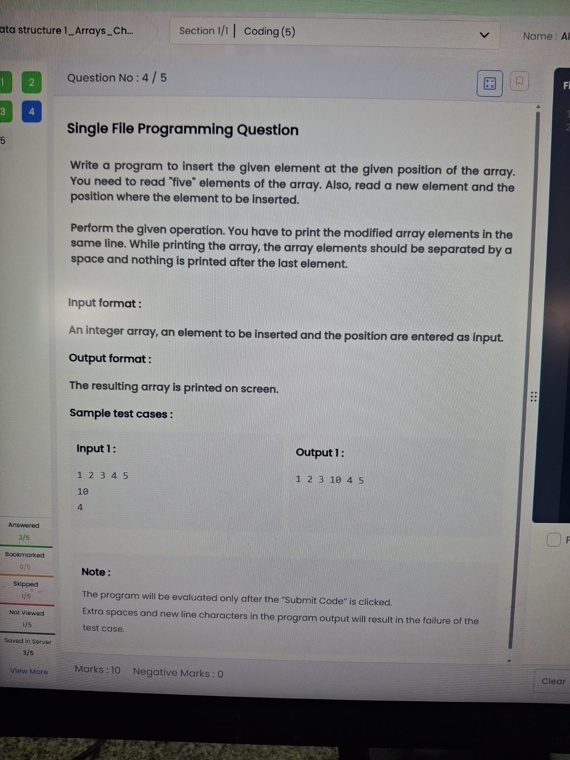

import java.util.*;

public class Main {

public static void main(String[] args) {

Scanner sc = new Scanner(System.in);

int[] a = new int[5];

for(int i = 0; i < 5; i++)

a[i] = sc.nextInt();

int x = sc.nextInt();

int pos = sc.nextInt();

int[] b = new int[6];

for(int i = 0, j = 0; i < 6; i++) {

if(i == pos - 1)

b[i] = x;

else

b[i] = a[j++];

}

for(int i = 0; i < 6; i++) {

System.out.print(b[i]);

if(i < 5) System.out.print(" ")} }

}

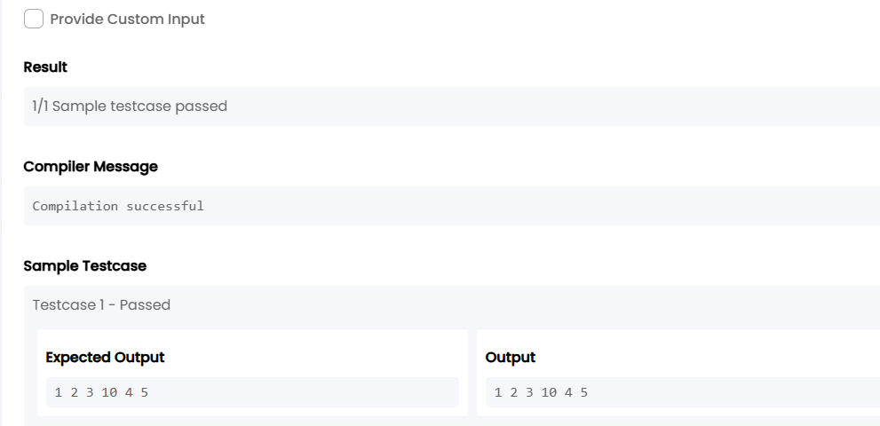

TASK5:

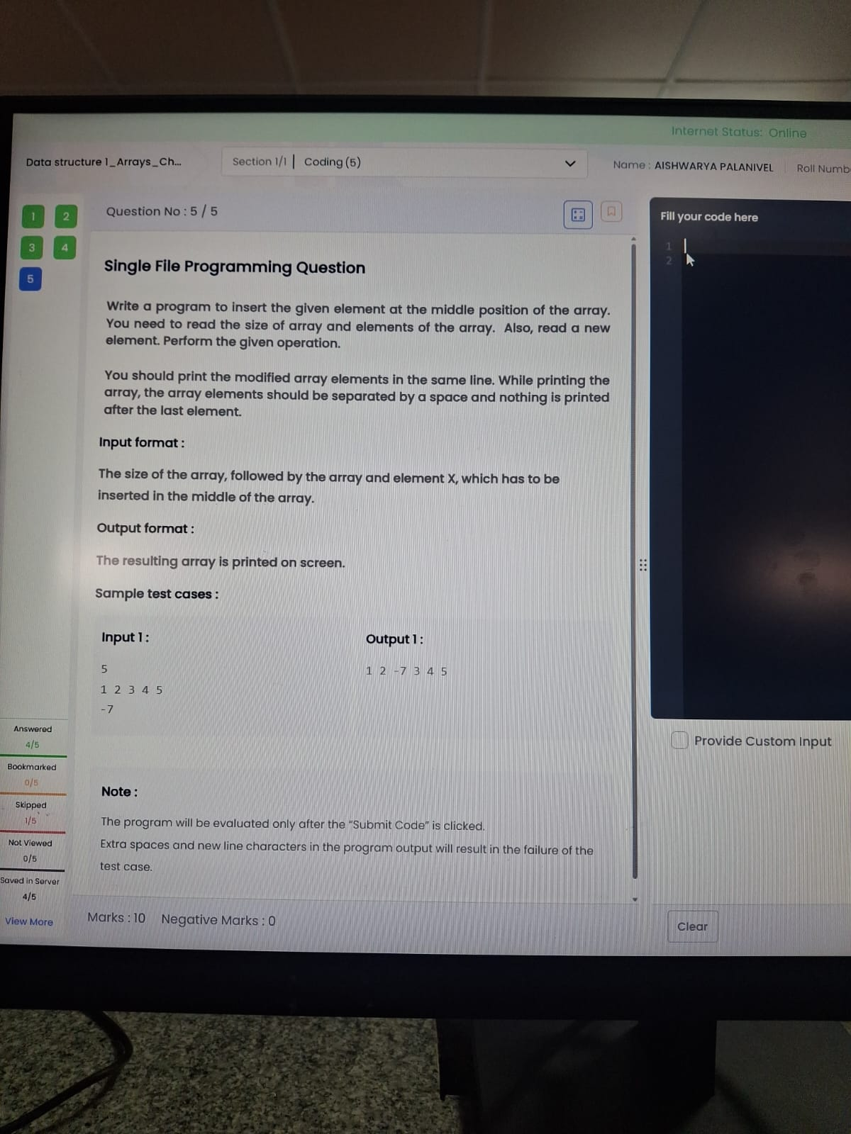

import java.util.*;

public class Main {

public static void main(String[] args) {

Scanner sc = new Scanner(System.in);

int n = sc.nextInt();

int[] a = new int[n];

for(int i = 0; i < n; i++)

a[i] = sc.nextInt();

int x = sc.nextInt();

int[] b = new int[n + 1];

int mid = n / 2;

for(int i = 0, j = 0; i < n + 1; i++) {

if(i == mid)

b[i] = x;

else

b[i] = a[j++];

}

for(int i = 0; i < n + 1; i++) {

System.out.print(b[i]);

if(i < n) System.out.print(" ");}}}

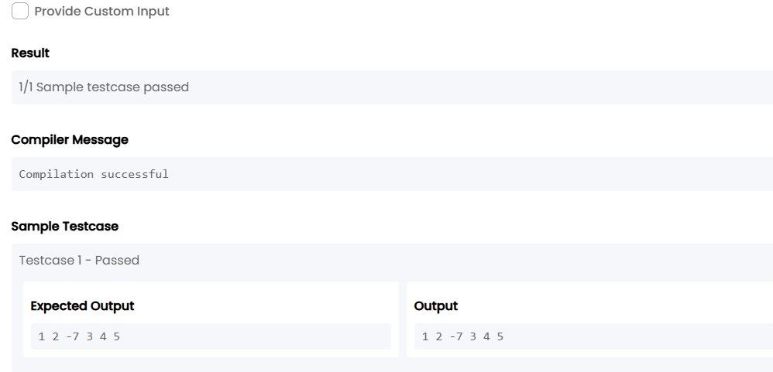

**2. Data structure 1_Arrays_Chapter 2**

TASK6:

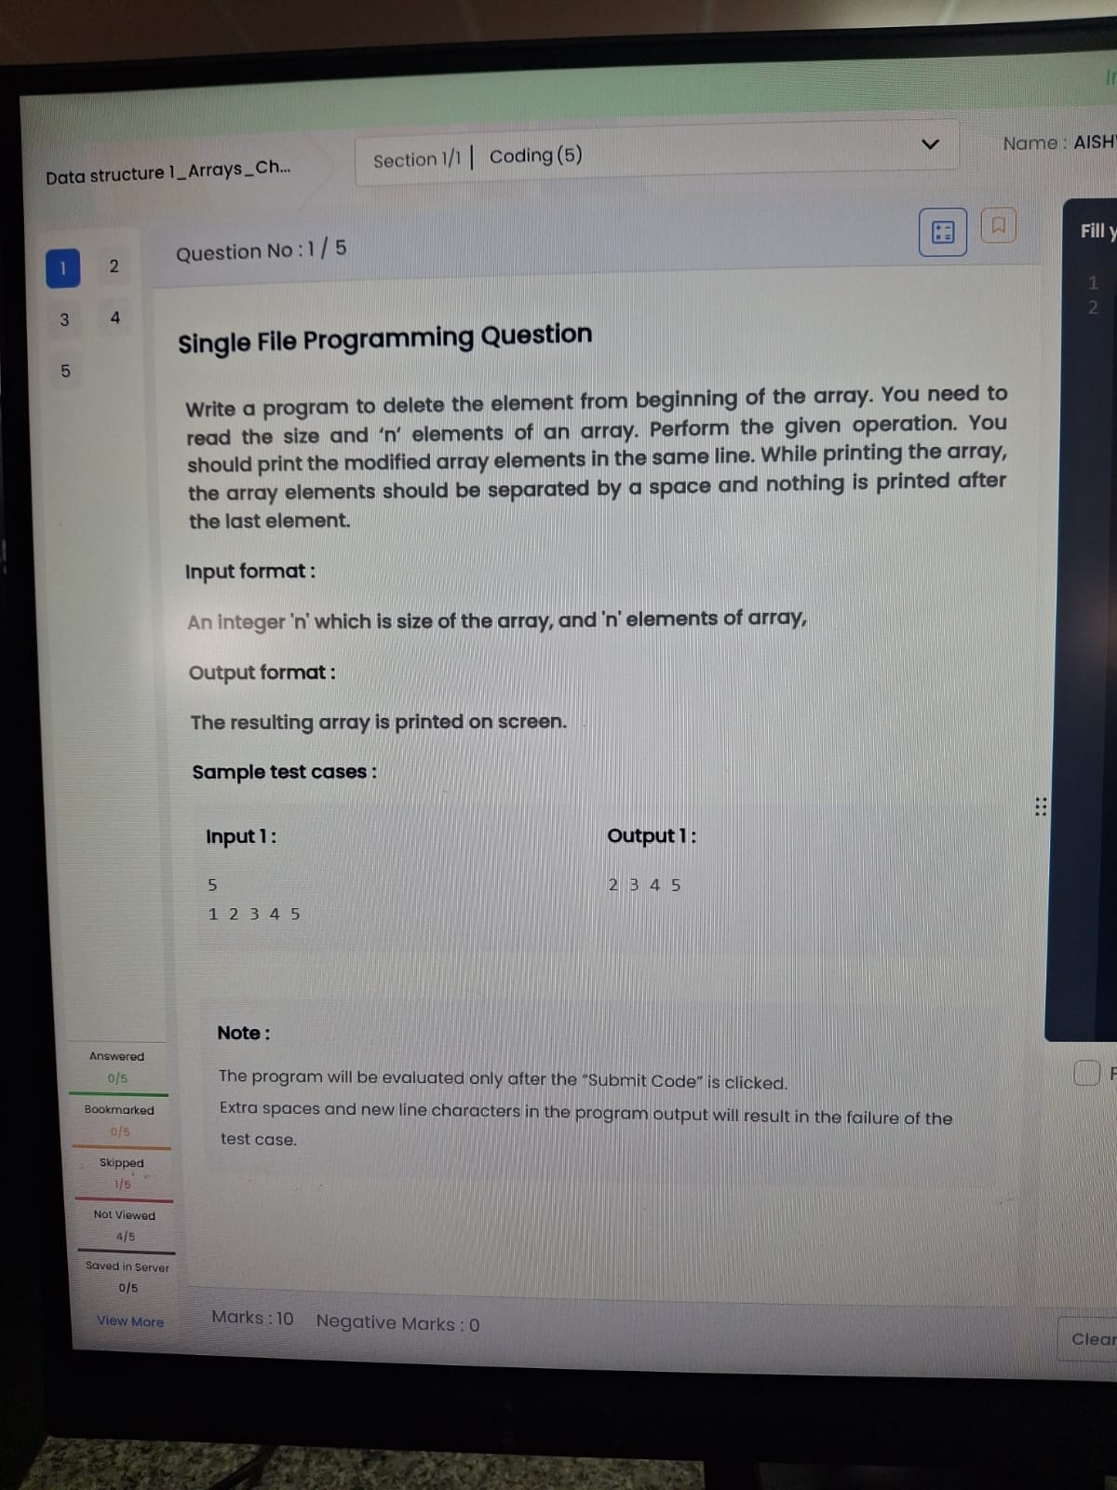

import java.util.*;

public class Main {

public static void main(String[] args) {

Scanner sc = new Scanner(System.in);

int n = sc.nextInt();

int[] a = new int[n];

for(int i = 0; i < n; i++)

a[i] = sc.nextInt();

for(int i = 1; i < n; i++) {

System.out.print(a[i]);

if(i < n-1) System.out.print(" ");

}

}

}

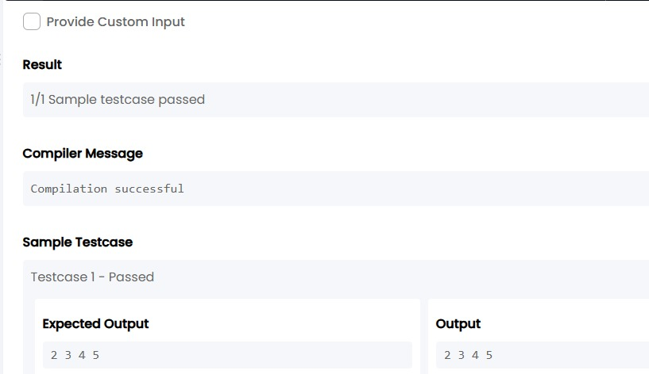

TASK7:

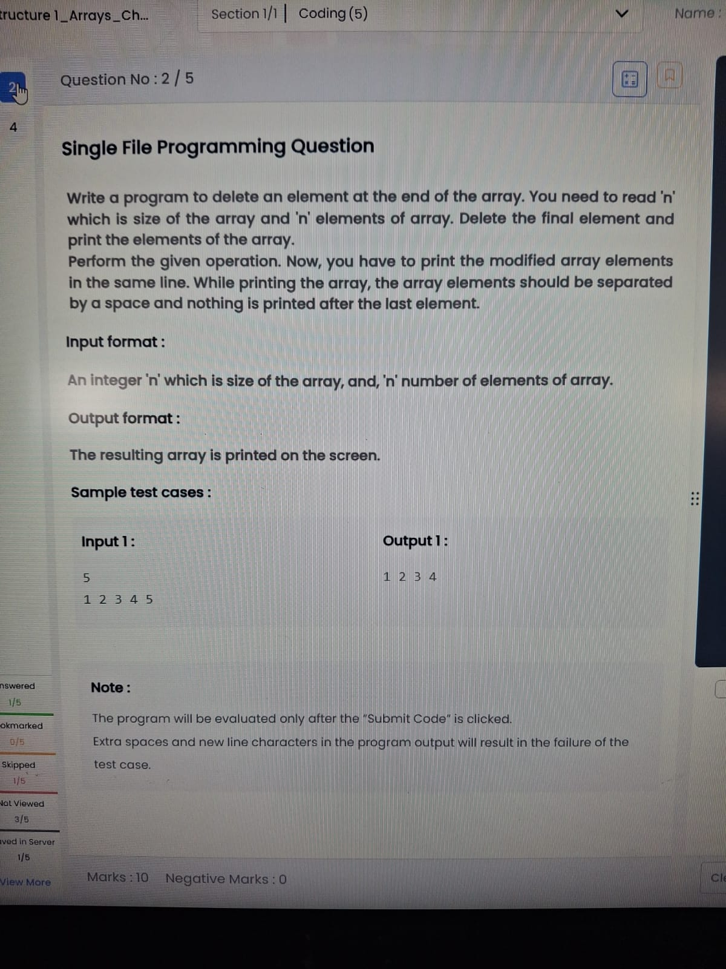

import java.util.Scanner;

public class Main {

public static void main(String[] args) {

Scanner sc = new Scanner(System.in);

int n = sc.nextInt();

int[] a = new int[n];

for(int i = 0; i < n; i++)

a[i] = sc.nextInt();

for(int i = 0; i < n - 1; i++) {

System.out.print(a[i]);

if(i < n - 2)

System.out.print(" ");

}

}

}

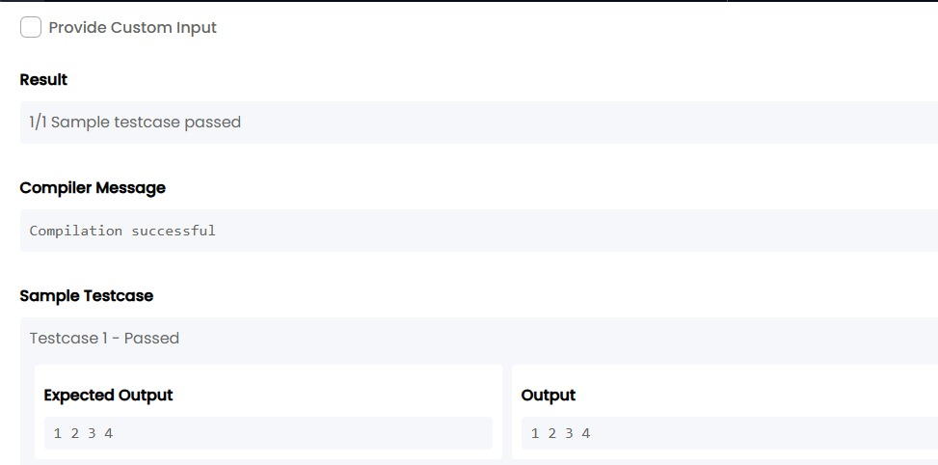

TASK8:

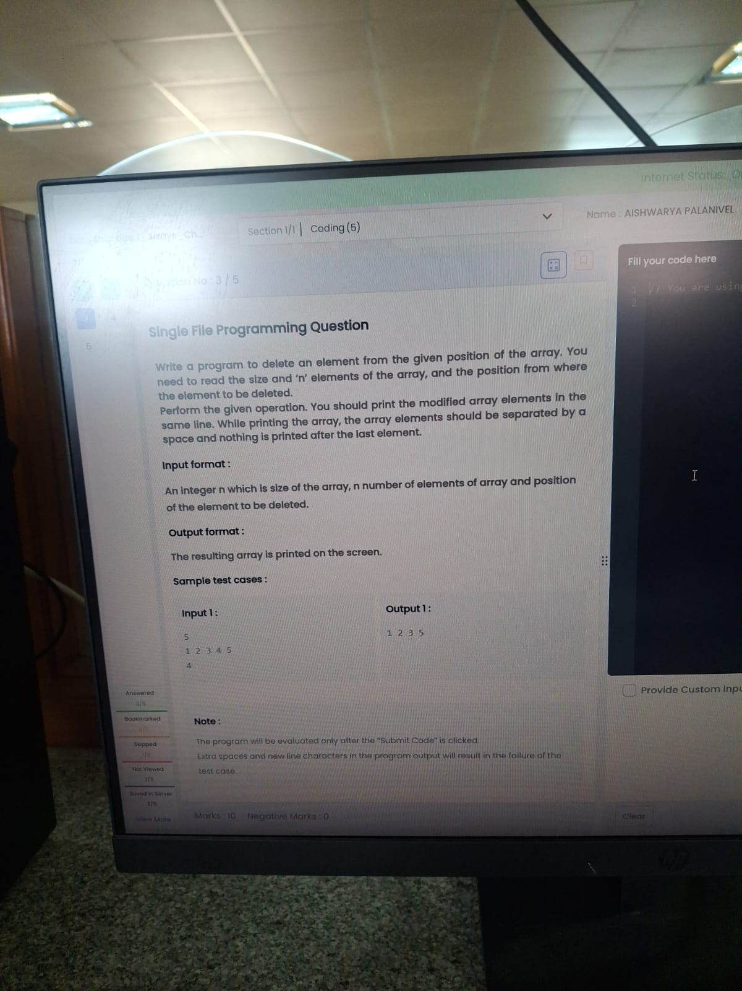

import java.util.Scanner;

public class Main {

public static void main(String[] args) {

Scanner sc = new Scanner(System.in);

int n = sc.nextInt();

int[] a = new int[n];

for(int i = 0; i < n; i++)

a[i] = sc.nextInt();

int pos = sc.nextInt(); // 1-based position

for(int i = 0; i < n; i++) {

if(i != pos - 1) {

System.out.print(a[i]);

if(i < n - 1 && !(i == n - 2 && pos == n))

System.out.print(" ");

}

}

}

}

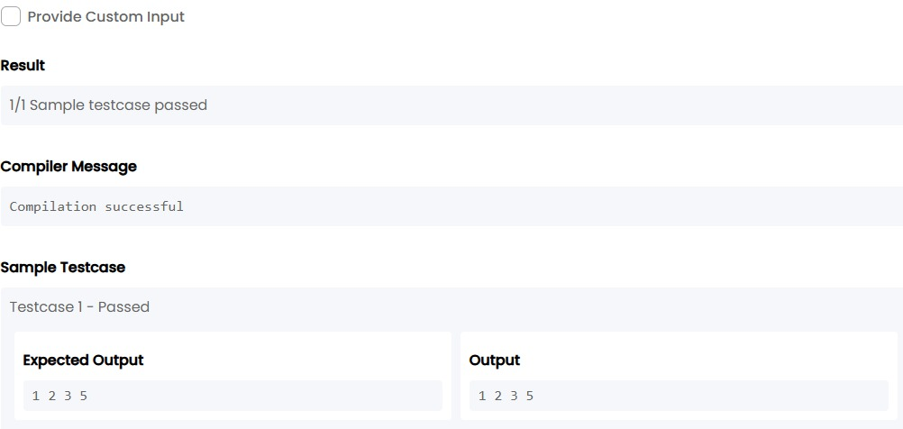

TASK9:

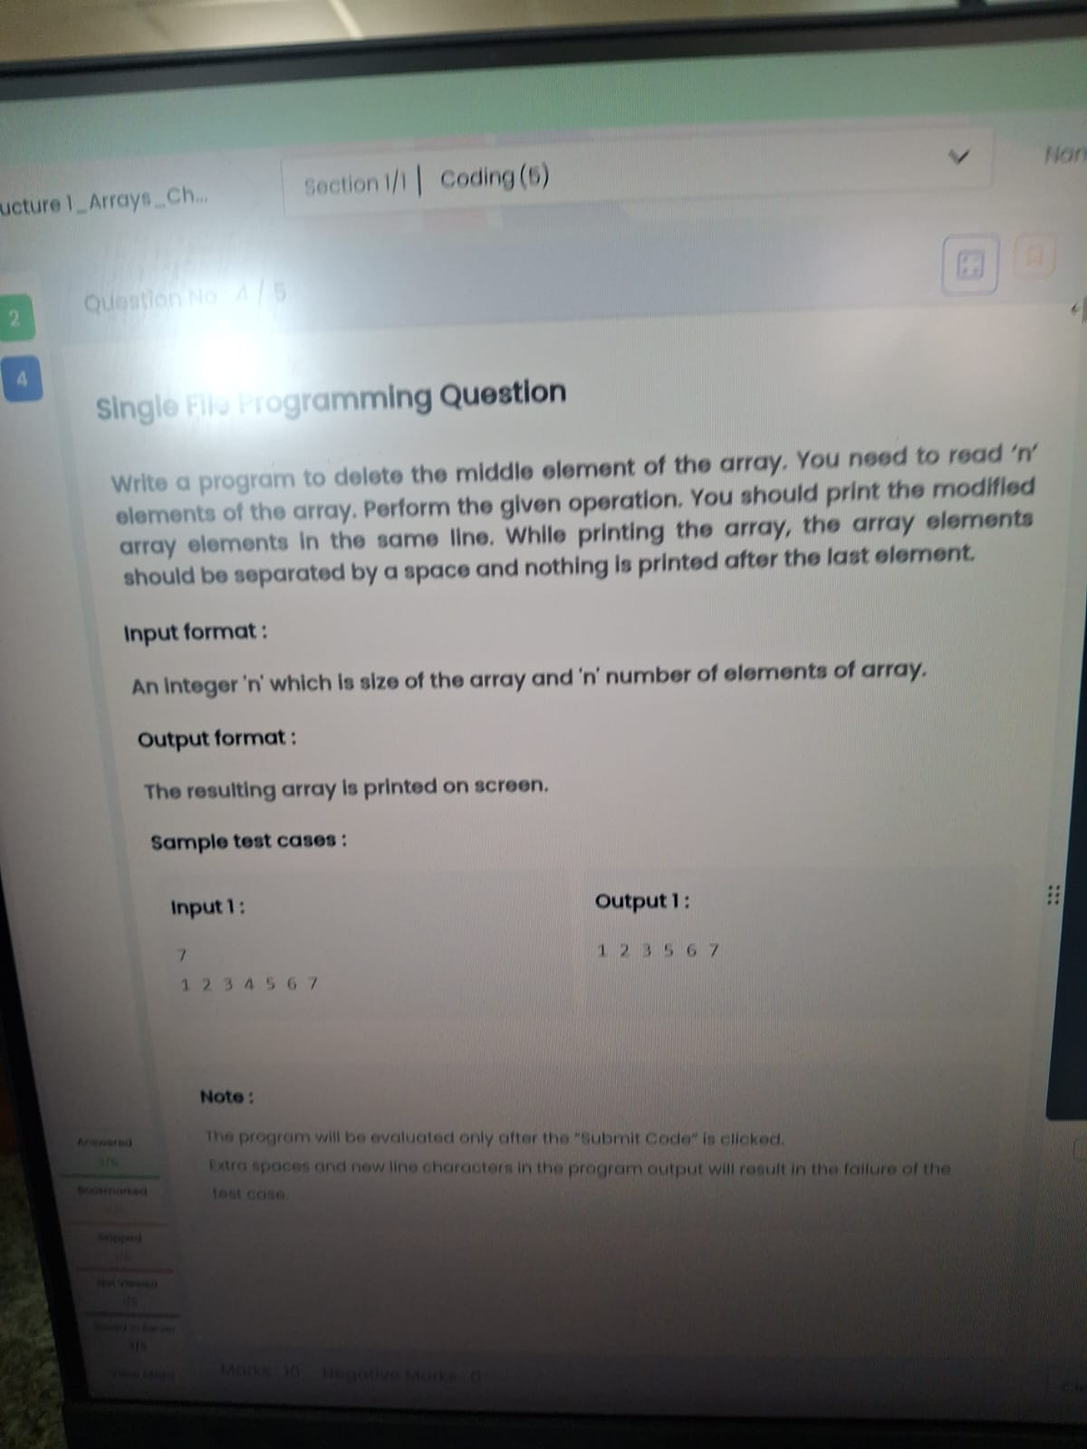

import java.util.Scanner;

public class Main {

public static void main(String[] args) {

Scanner sc = new Scanner(System.in);

int n = sc.nextInt();

int[] a = new int[n];

for(int i = 0; i < n; i++)

a[i] = sc.nextInt();

int mid = n / 2; // middle index

for(int i = 0; i < n; i++) {

if(i != mid) {

System.out.print(a[i]);

if(i != n - 1 && !(i == n - 2 && mid == n - 1))

System.out.print(" ");

}

}

}

}

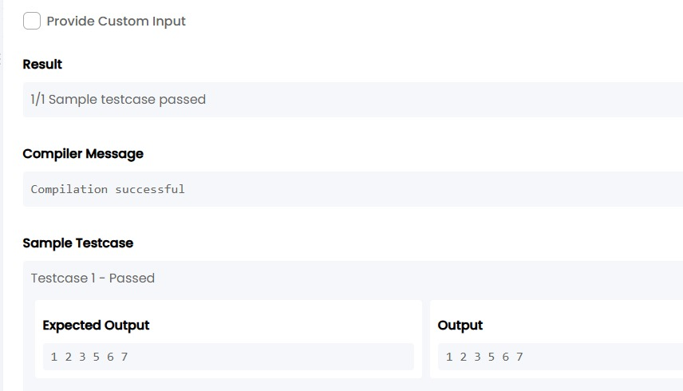

TASK10:

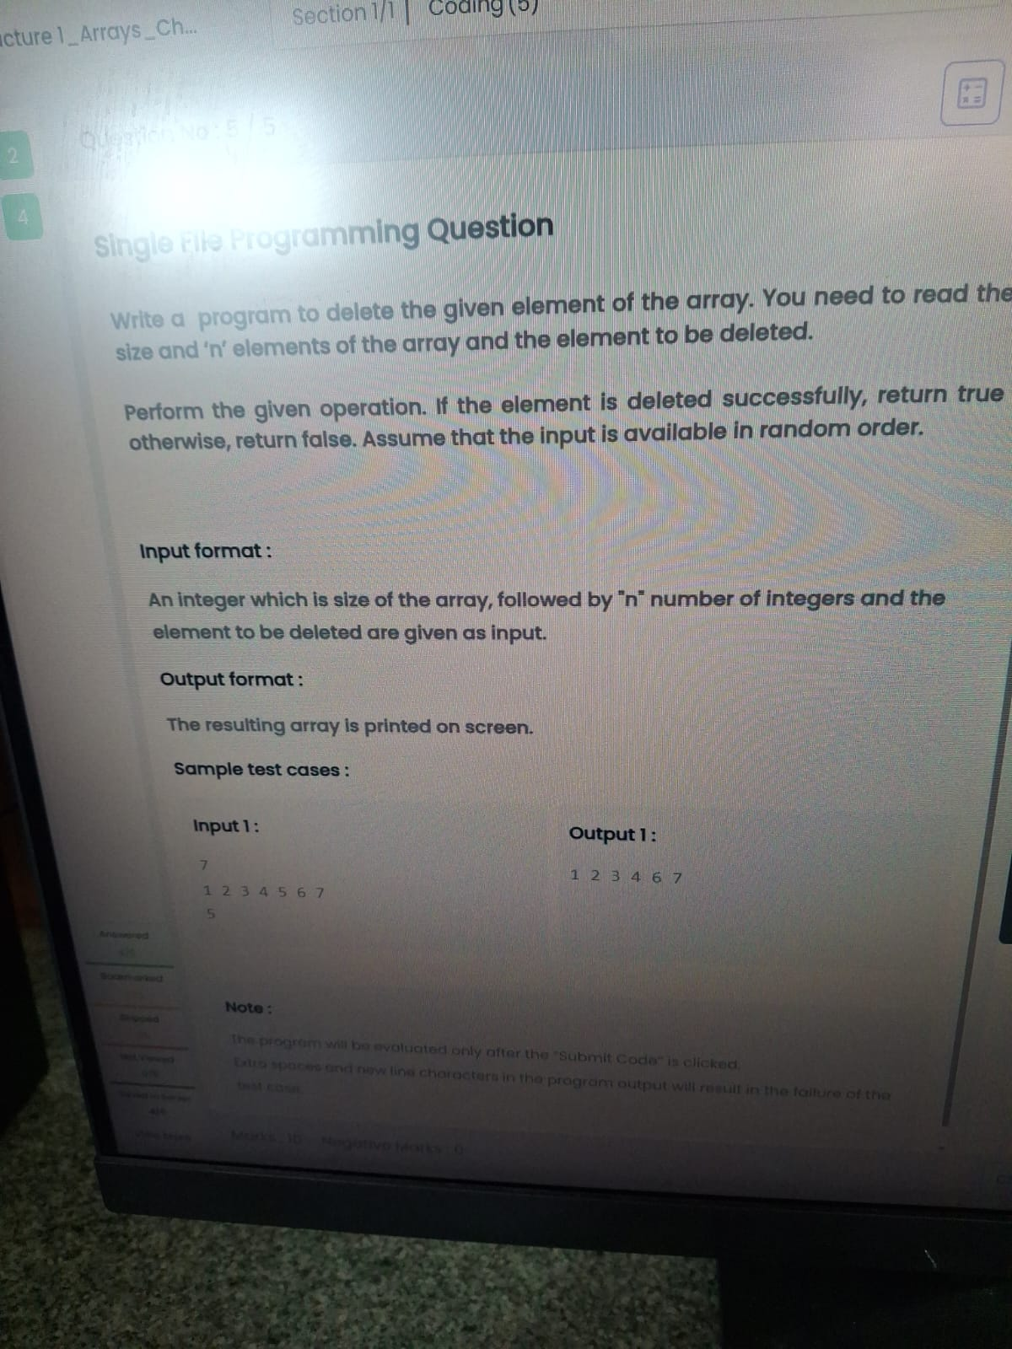

import java.util.Scanner;

public class Main {

public static void main(String[] args) {

Scanner sc = new Scanner(System.in);

int n = sc.nextInt();

int[] a = new int[n];

for(int i = 0; i < n; i++)

a[i] = sc.nextInt();

int del = sc.nextInt();

boolean found = false;

for(int i = 0; i < n; i++){

if(a[i] == del && !found){

found = true;

continue;

}

System.out.print(a[i]);

if(i < n - 1)

System.out.print(" ");

}

if(!found)

System.out.print("false");

}

}

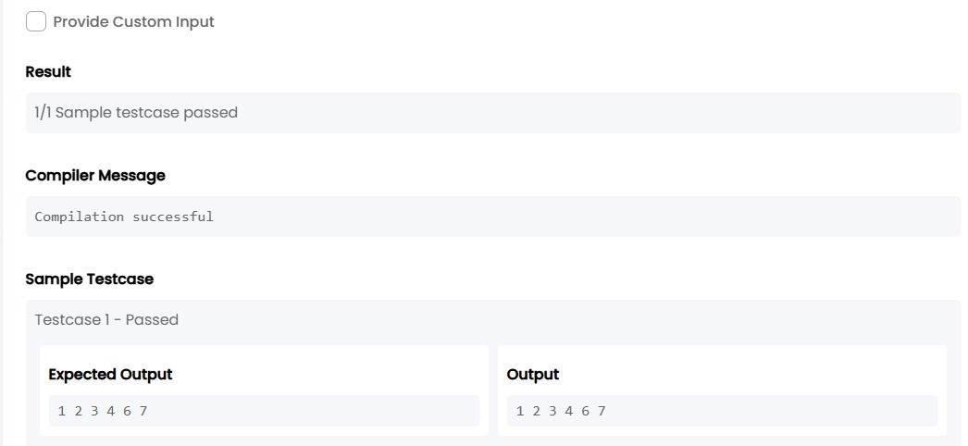

**3. Data structure 4_Search & Sorting_Chapter1**

TASK11:

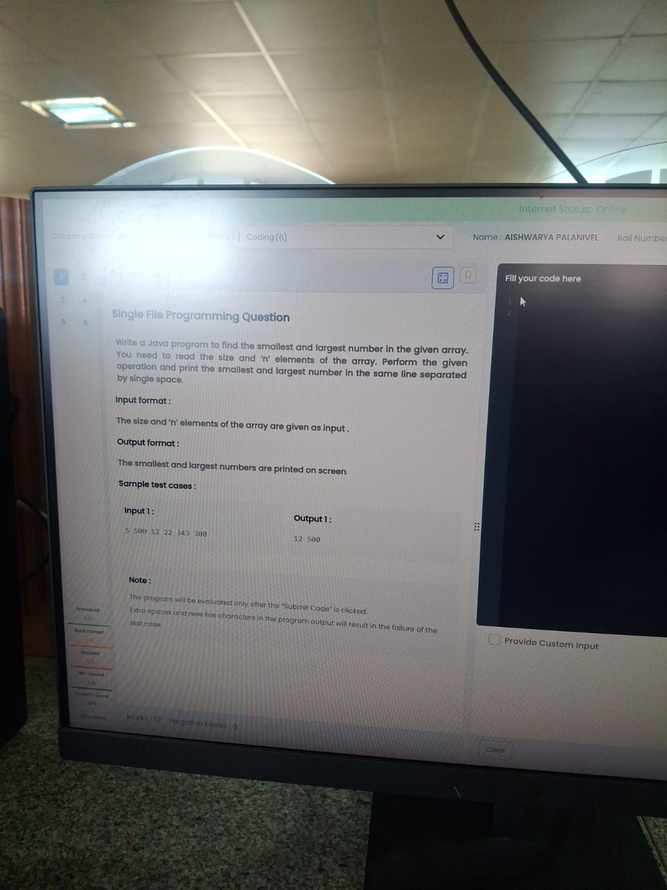

import java.util.Scanner;

public class Main {

public static void main(String[] args) {

Scanner sc = new Scanner(System.in);

int n = sc.nextInt();

int min = Integer.MAX_VALUE;

int max = Integer.MIN_VALUE;

for(int i = 0; i < n; i++){

int num = sc.nextInt();

if(num < min) min = num;

if(num > max) max = num;

}

System.out.print(min + " " + max);

}

}

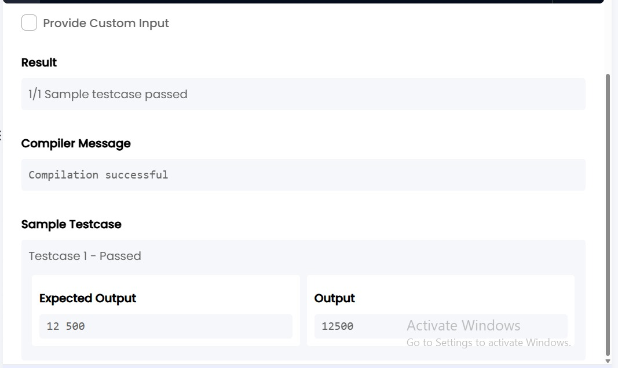

TASK12:

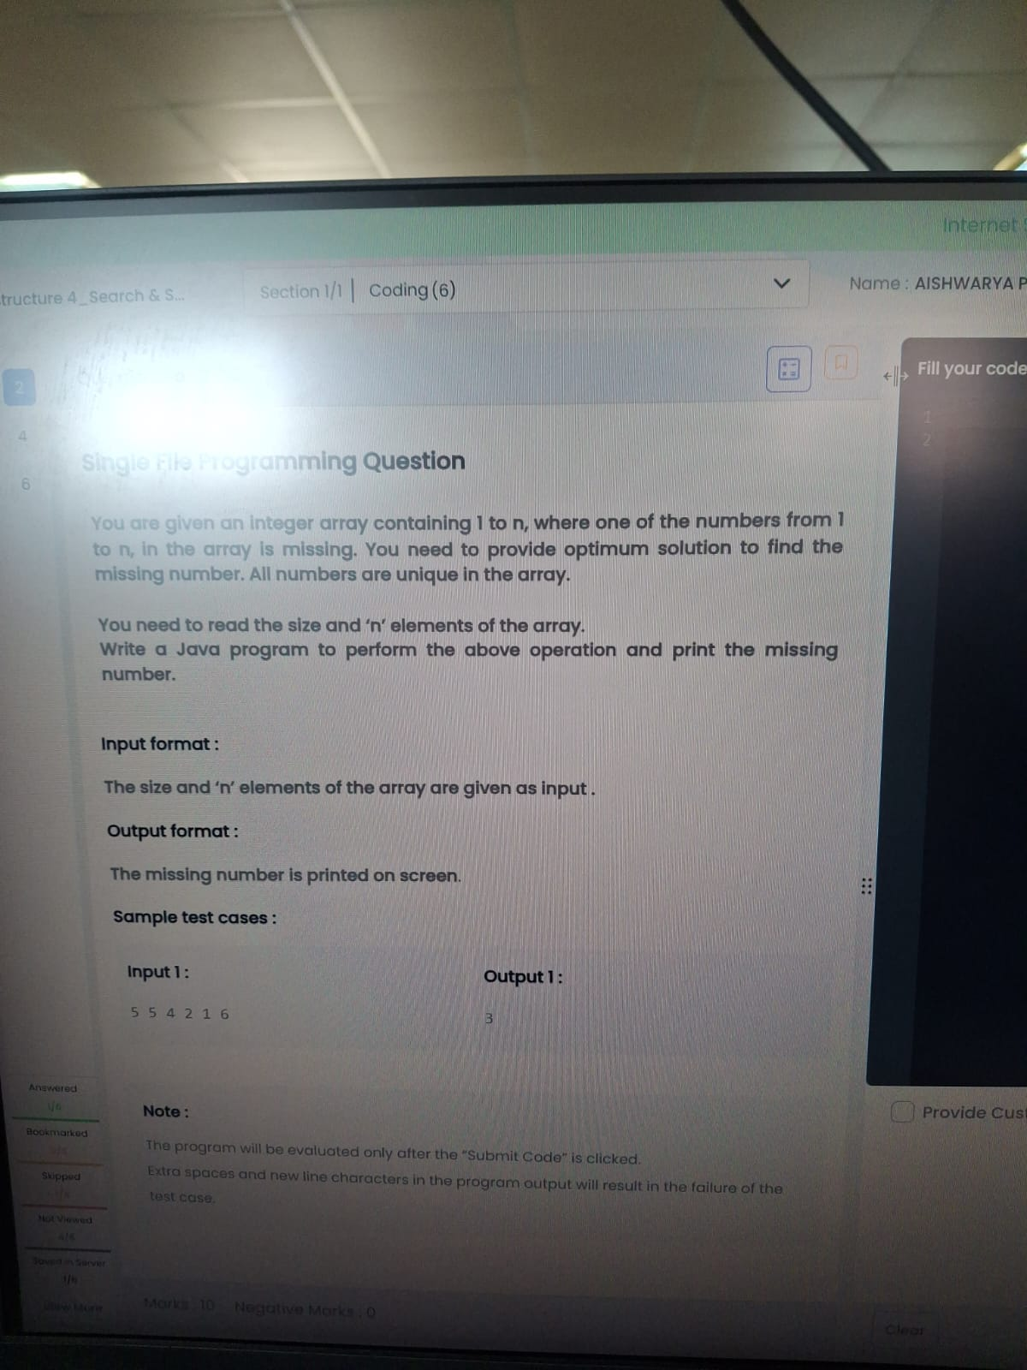

import java.util.Scanner;

import java.util.Arrays;

public class Main {

public static void main(String[] args) {

Scanner sc = new Scanner(System.in);

int n = sc.nextInt();

int[] a = new int[n];

for(int i = 0; i < n; i++)

a[i] = sc.nextInt();

Arrays.sort(a);

for(int i = 0; i < n - 1; i++) {

if(a[i+1] - a[i] != 1) {

System.out.print(a[i] + 1);

return;

}

}

}

}

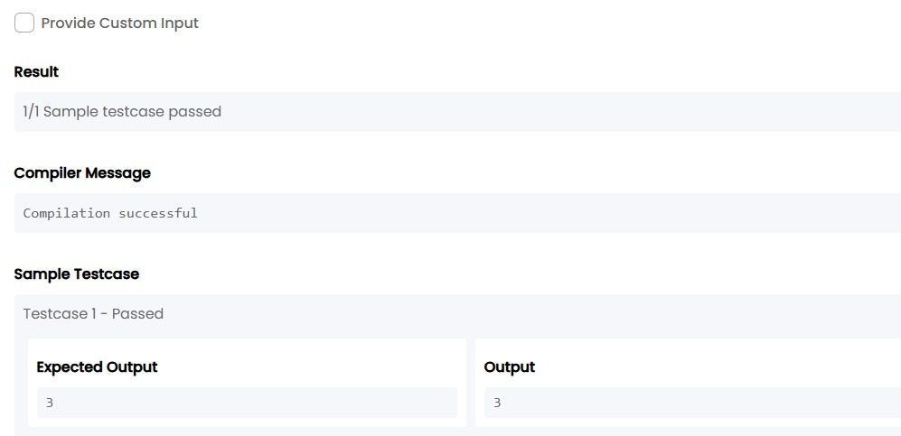

TASK13:

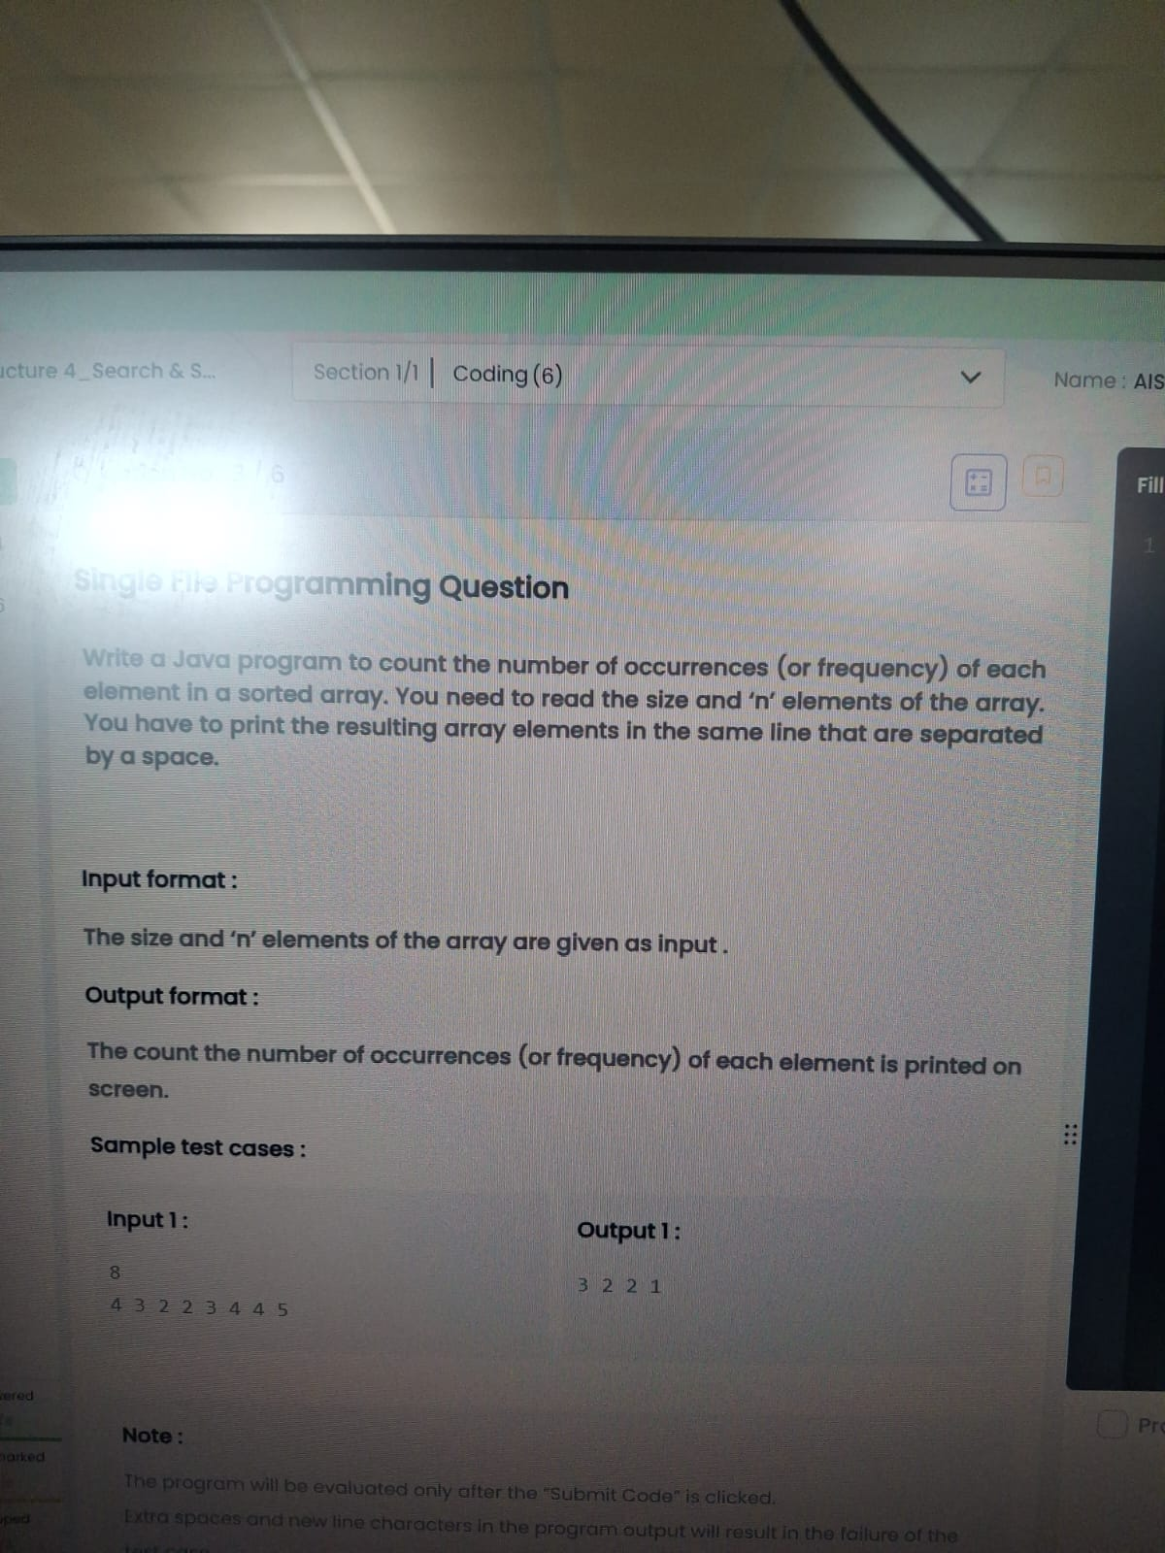

import java.util.*;

public class Main {

public static void main(String[] args) {

Scanner sc = new Scanner(System.in);

int n = sc.nextInt();

int[] a = new int[n];

for(int i = 0; i < n; i++)

a[i] = sc.nextInt();

LinkedHashMap<Integer,Integer> map = new LinkedHashMap<>();

for(int i = 0; i < n; i++)

map.put(a[i], map.getOrDefault(a[i],0)+1);

for(int val : map.values())

System.out.print(val + " ");

}

}

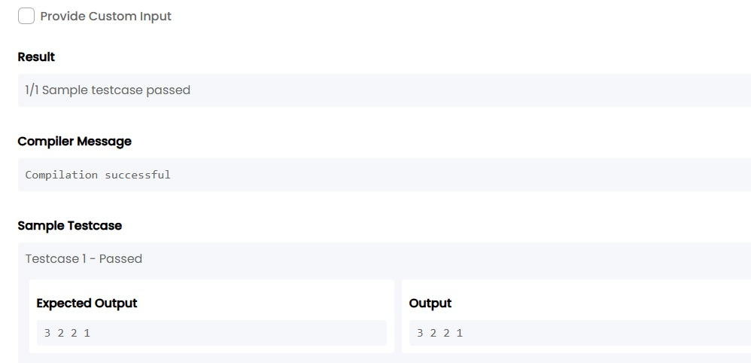

TASK14:

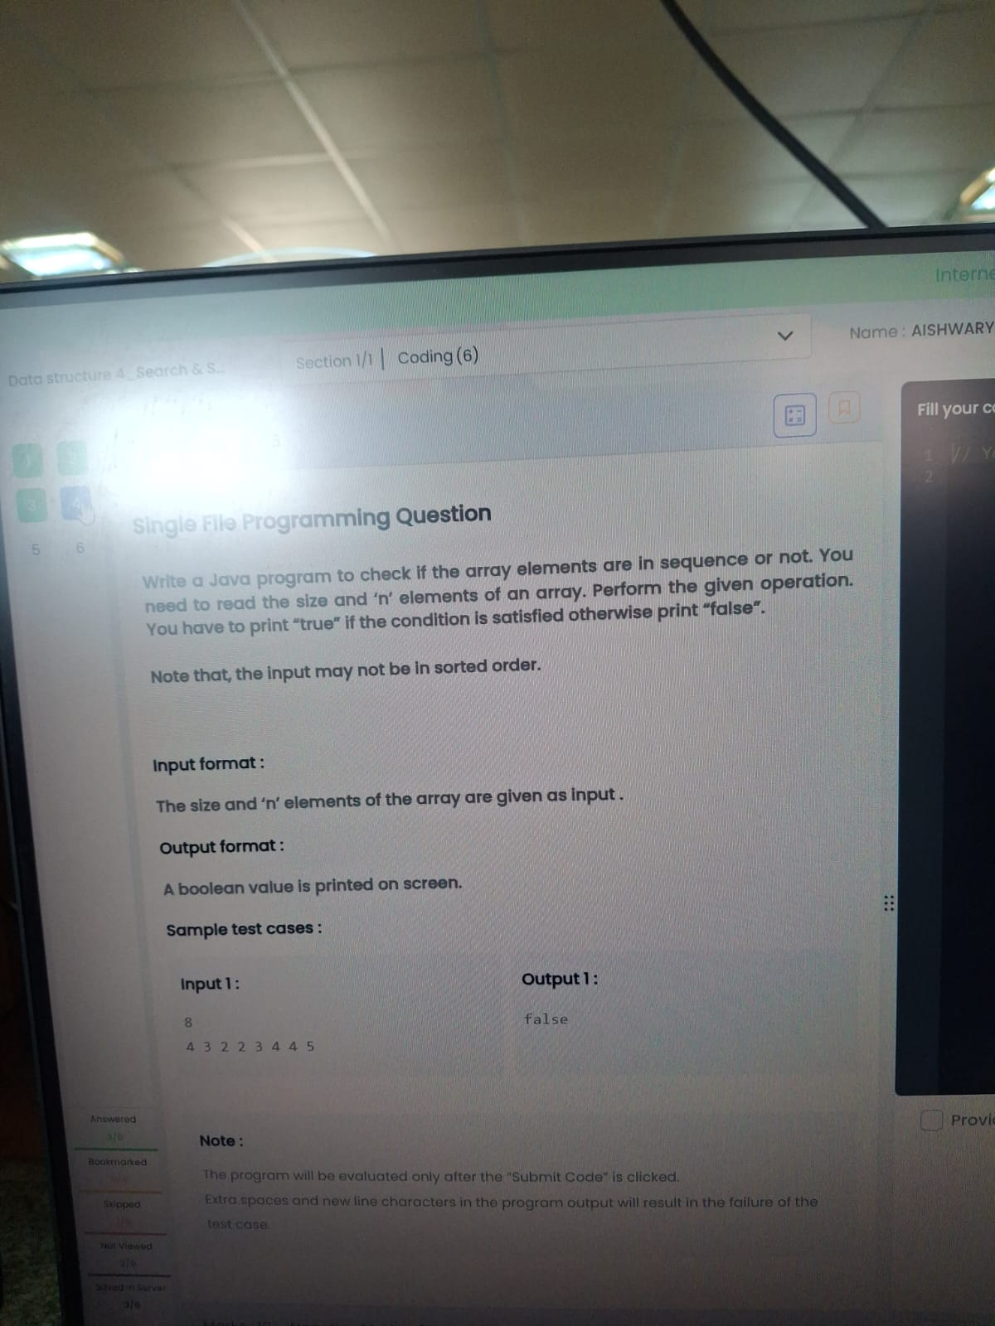

import java.util.*;

public class Main {

public static void main(String[] args) {

Scanner sc = new Scanner(System.in);

int n = sc.nextInt();

int[] a = new int[n];

for(int i = 0; i < n; i++)

a[i] = sc.nextInt();

Arrays.sort(a);

boolean flag = true;

for(int i = 1; i < n; i++) {

if(a[i] != a[i-1] + 1) {

flag = false;

break;

}

}

System.out.print(flag);

}

}

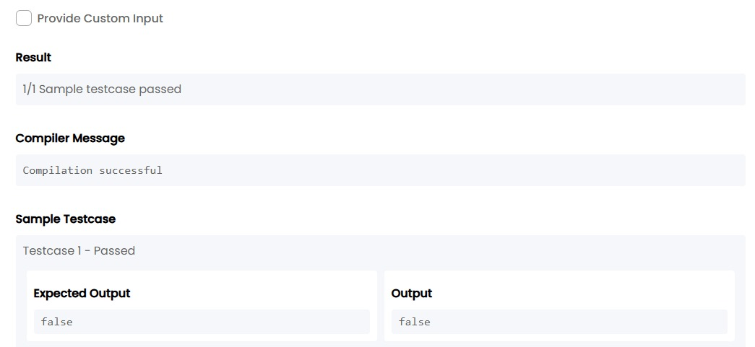

TASK15:

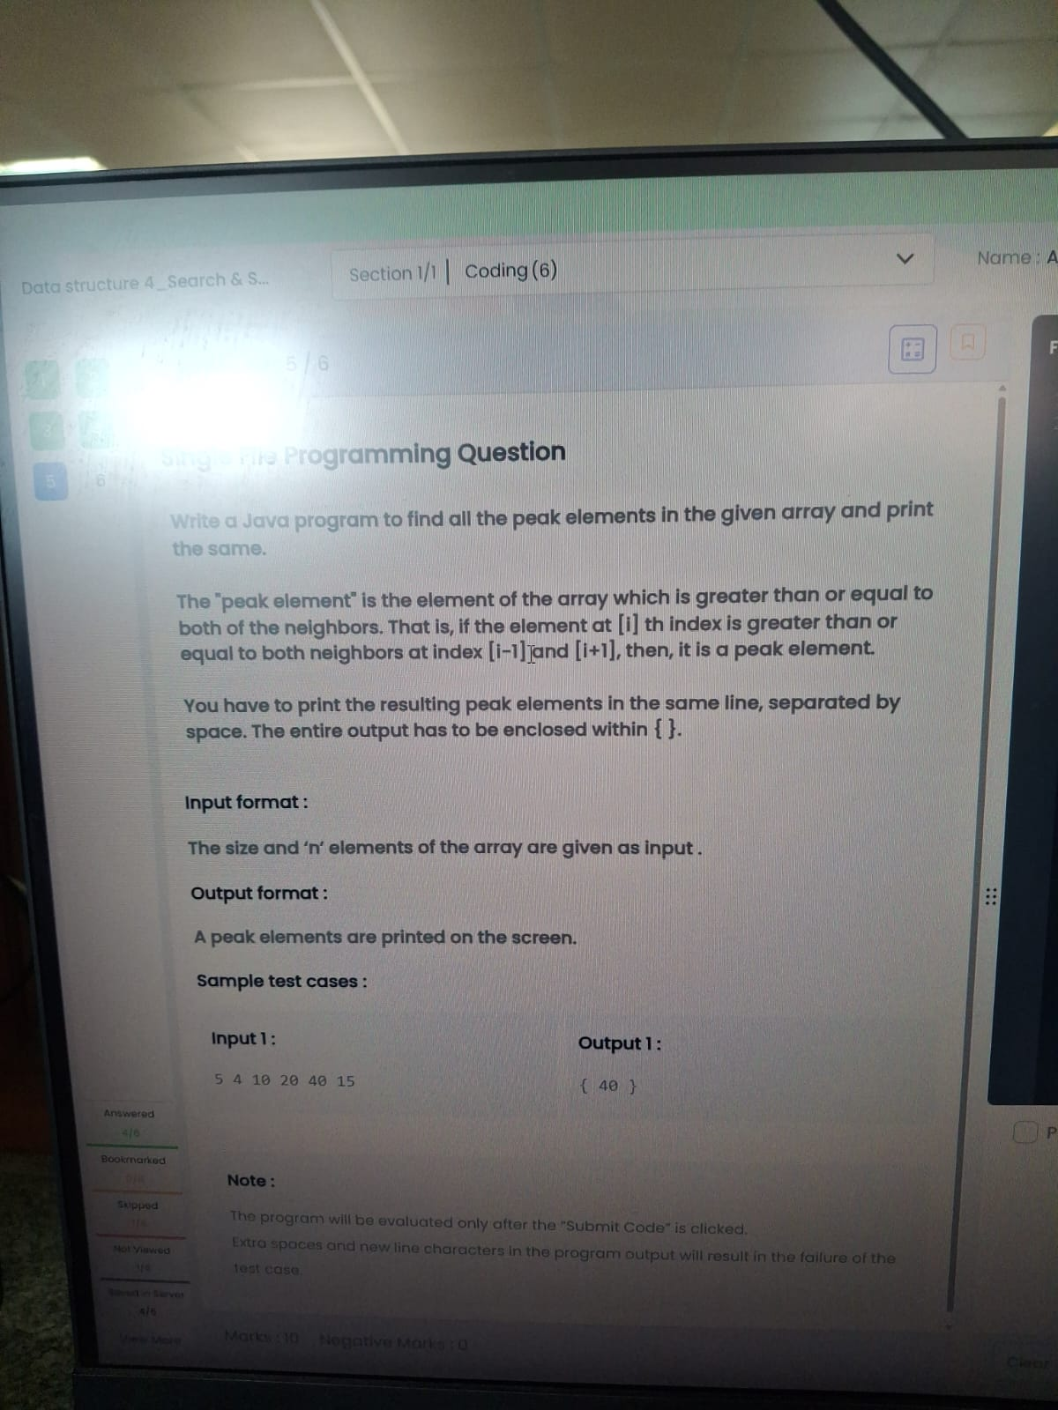

import java.util.*;

public class Main {

public static void main(String[] args) {

Scanner sc = new Scanner(System.in);

int n = sc.nextInt();

int[] a = new int[n];

for (int i = 0; i < n; i++)

a[i] = sc.nextInt();

System.out.print("{ ");

boolean first = true;

for (int i = 1; i < n - 1; i++) {

if (a[i] >= a[i - 1] && a[i] >= a[i + 1]) {

if (!first)

System.out.print(" ");

System.out.print(a[i]);

first = false;

}

}

System.out.print(" }");

}

}

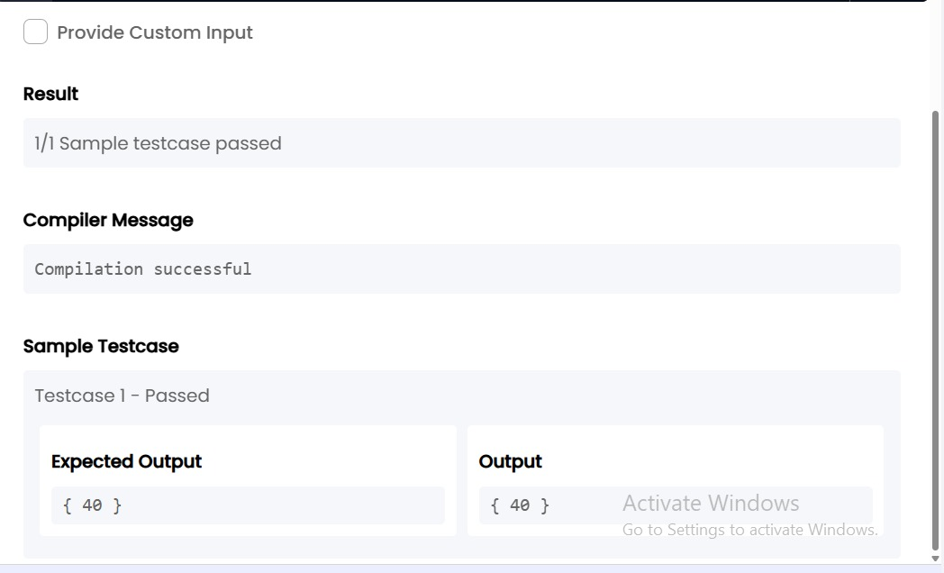

TASK16:

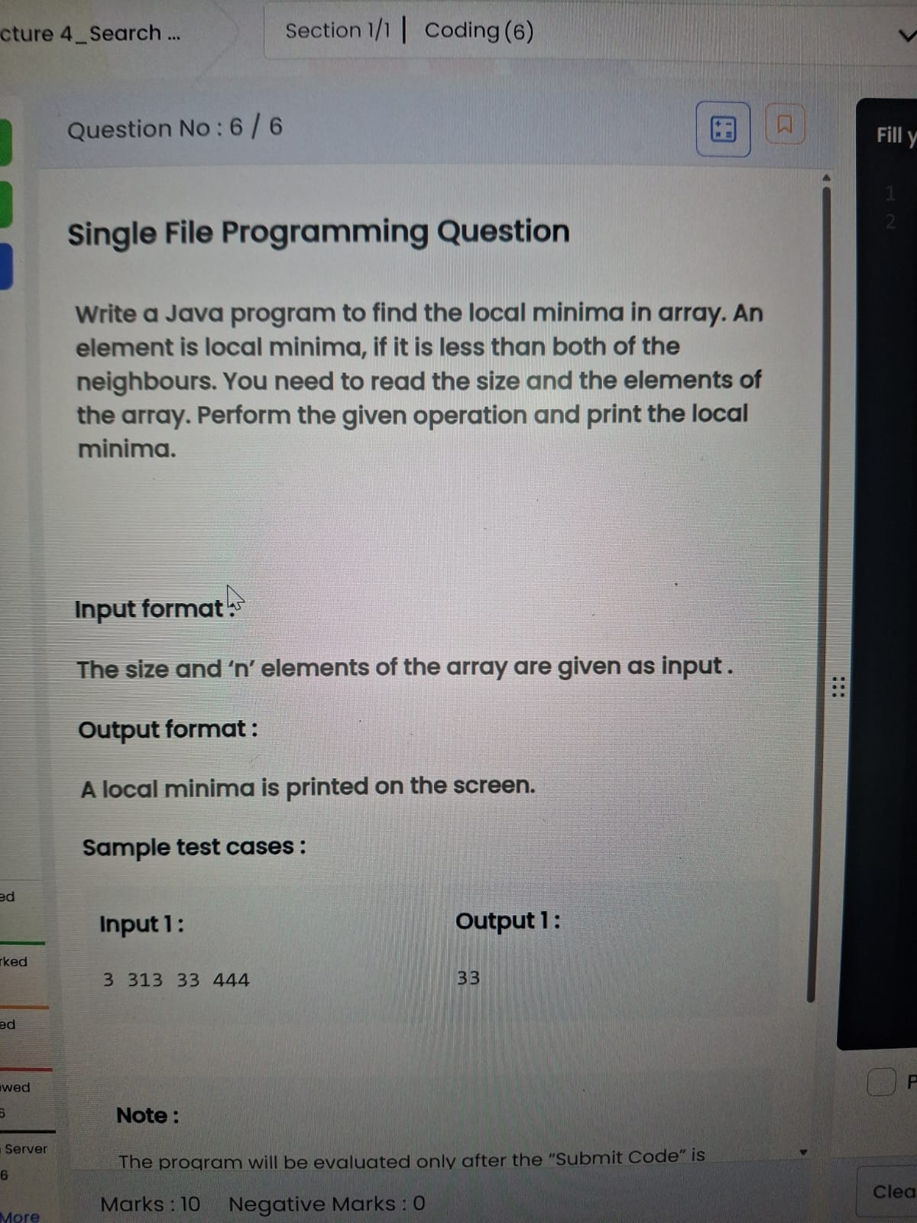

import java.util.*;

public class Main {

public static void main(String[] args) {

Scanner sc = new Scanner(System.in);

int n = sc.nextInt();

int[] a = new int[n];

for(int i=0;i<n;i++)

a[i]=sc.nextInt();

boolean first = true;

if(n==1){

System.out.print(a[0]);

return;

}

// First element

if(a[0] < a[1]){

System.out.print(a[0]);

first = false;

}

// Middle elements

for(int i=1;i<n-1;i++){

if(a[i] < a[i-1] && a[i] < a[i+1]){

if(!first) System.out.print(" ");

System.out.print(a[i]);

first = false;

}

}

// Last element

if(a[n-1] < a[n-2]){

if(!first) System.out.print(" ");

System.out.print(a[n-1]);}}}

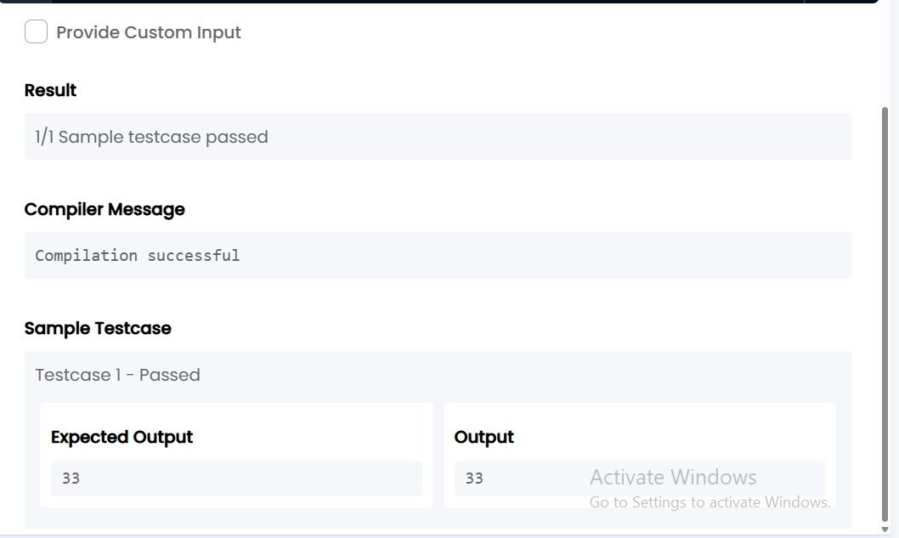

**4. Data structure 4_Search & Sorting_Chapter 2**

TASK17:

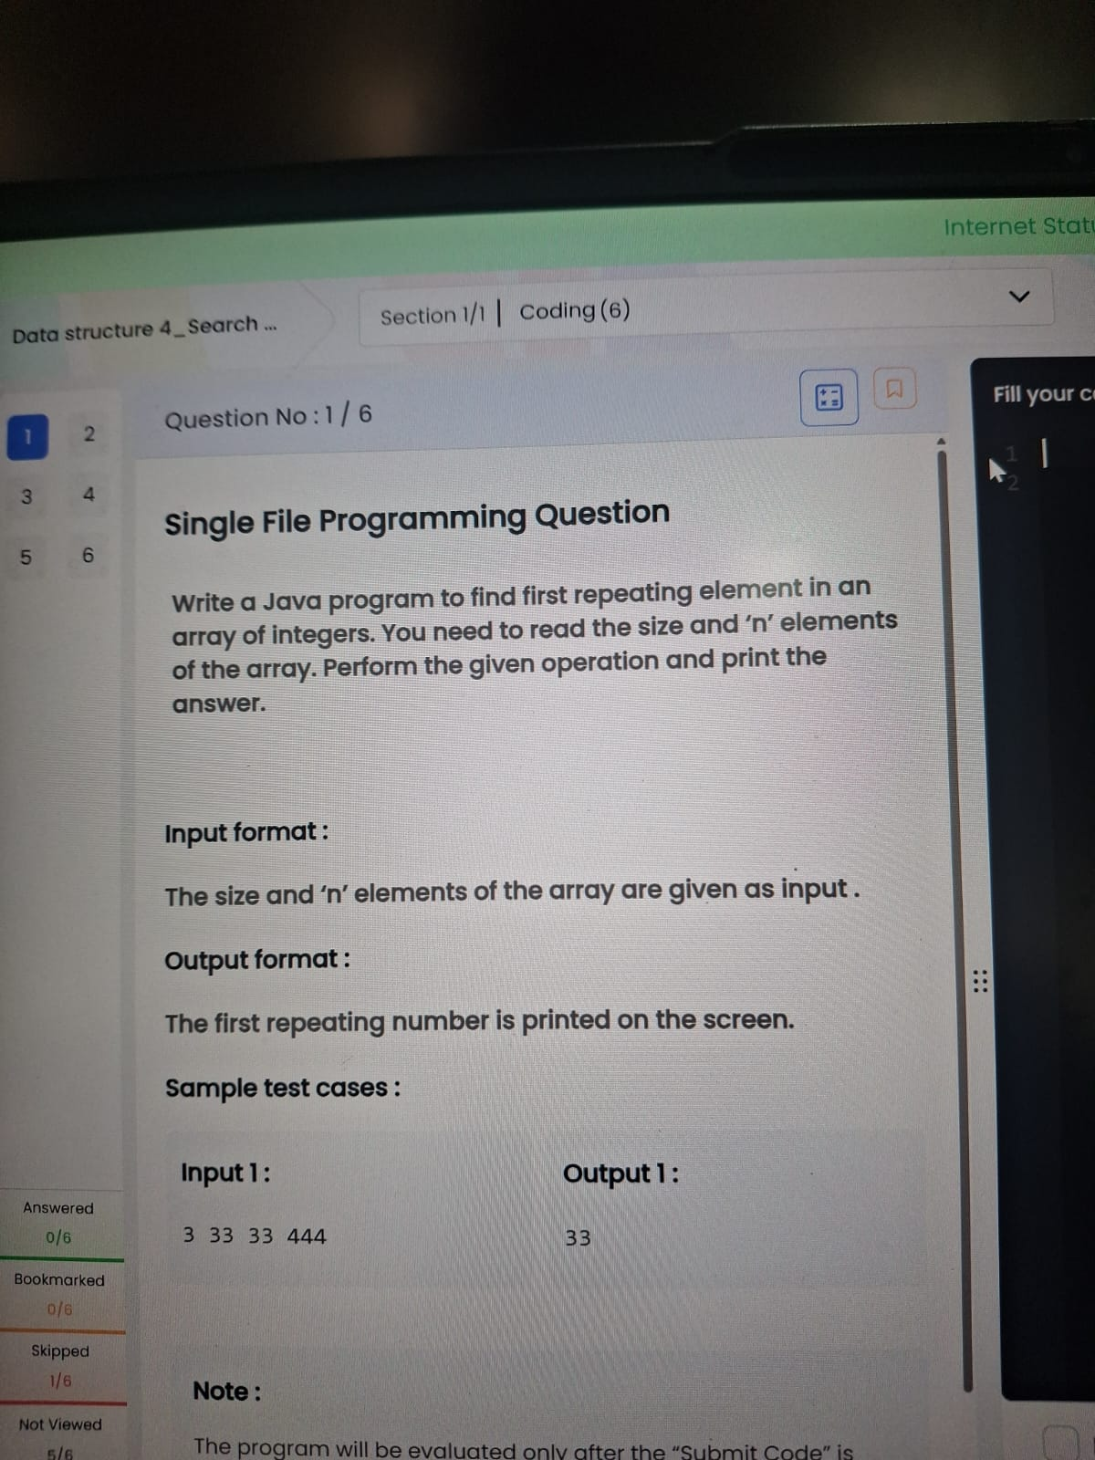

import java.util.*;

public class Main {

public static void main(String[] args) {

Scanner sc = new Scanner(System.in);

int n = sc.nextInt();

int[] a = new int[n];

for(int i=0;i<n;i++)

a[i]=sc.nextInt();

for(int i=0;i<n;i++){

for(int j=i+1;j<n;j++){

if(a[i]==a[j]){

System.out.print(a[i]);

return;

}

}

}

}

}

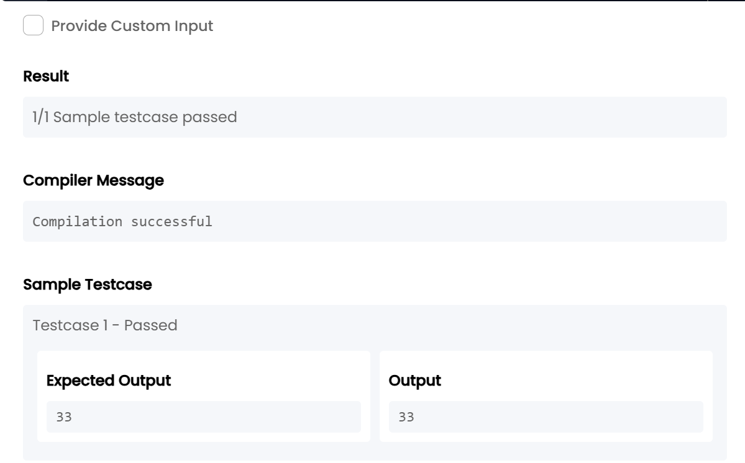

TASK18:

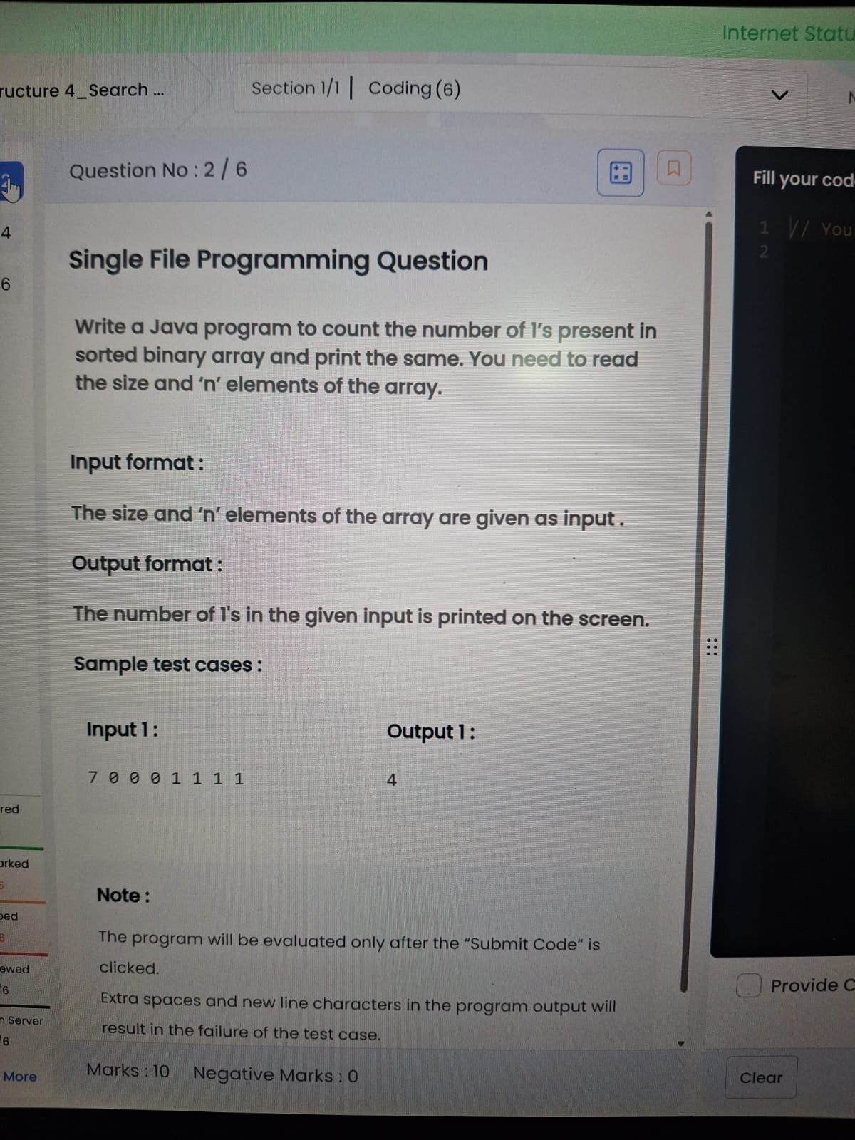

import java.util.*;

public class Main {

public static void main(String[] args) {

Scanner sc = new Scanner(System.in);

int n = sc.nextInt();

int count = 0;

for(int i = 0; i < n; i++)

if(sc.nextInt() == 1)

count++;

System.out.print(count);

}

}

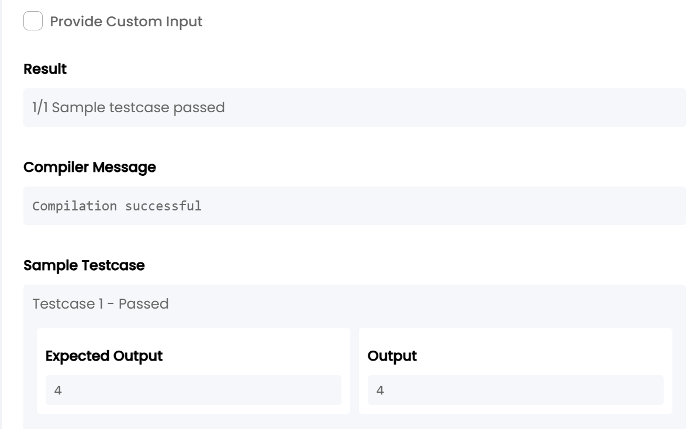

TASK19:

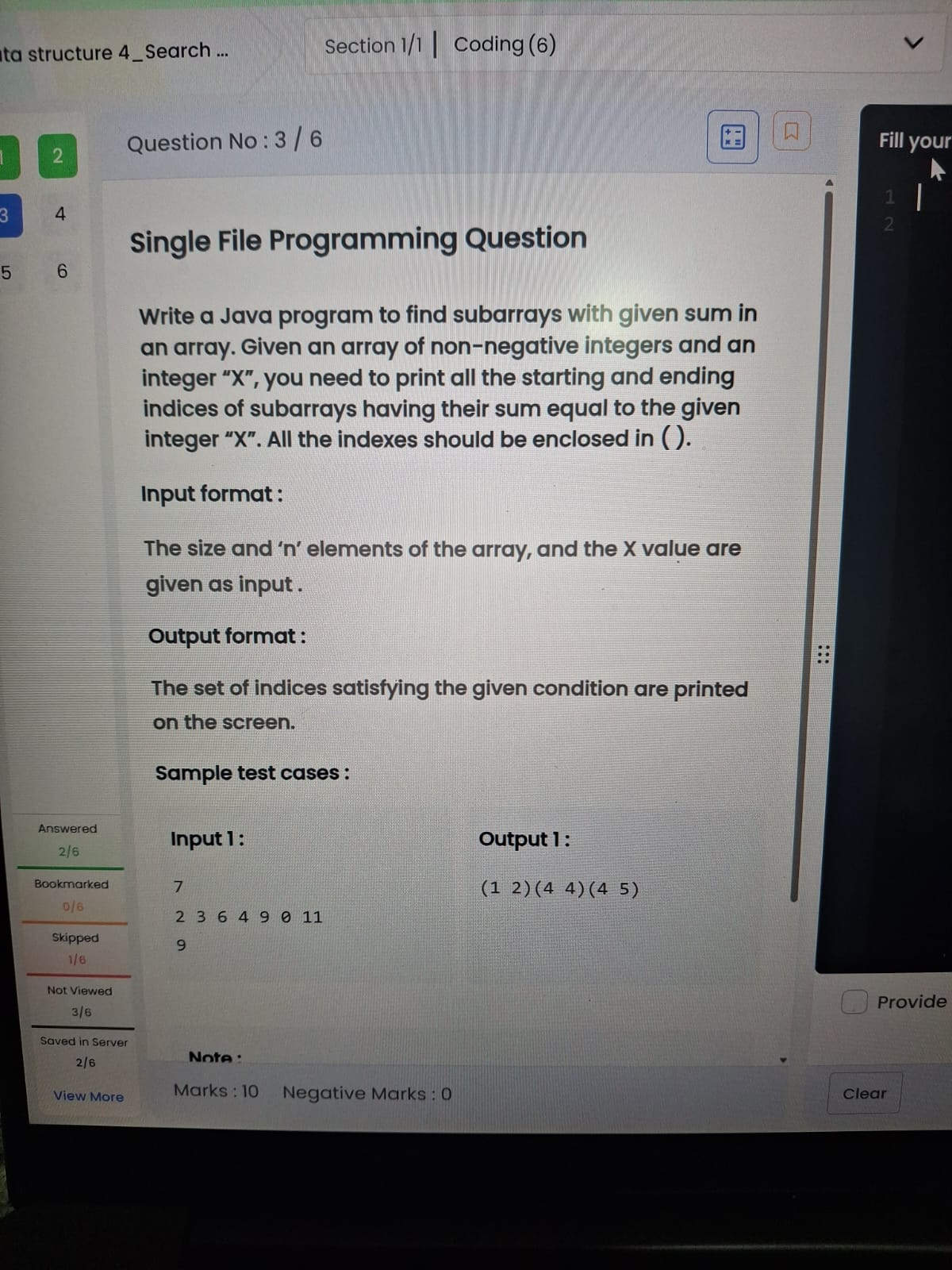

import java.util.*;

public class Main {

public static void main(String[] args) {

Scanner sc = new Scanner(System.in);

int n = sc.nextInt();

int[] a = new int[n];

for(int i=0;i<n;i++)

a[i]=sc.nextInt();

int x = sc.nextInt();

for(int i=0;i<n;i++){

int sum=0;

for(int j=i;j<n;j++){

sum+=a[j];

if(sum==x)

System.out.print("("+i+" "+j+")");

}

}

}

}

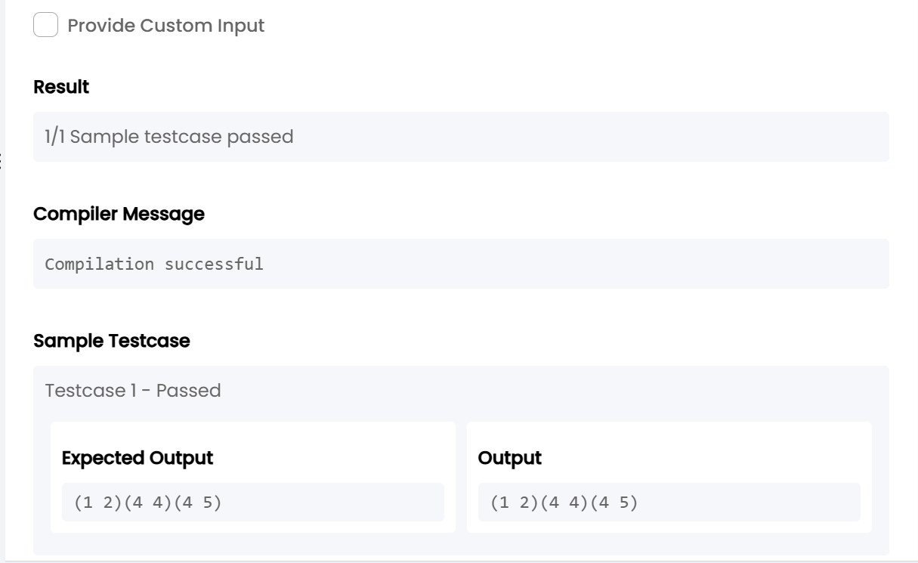

TASK20:

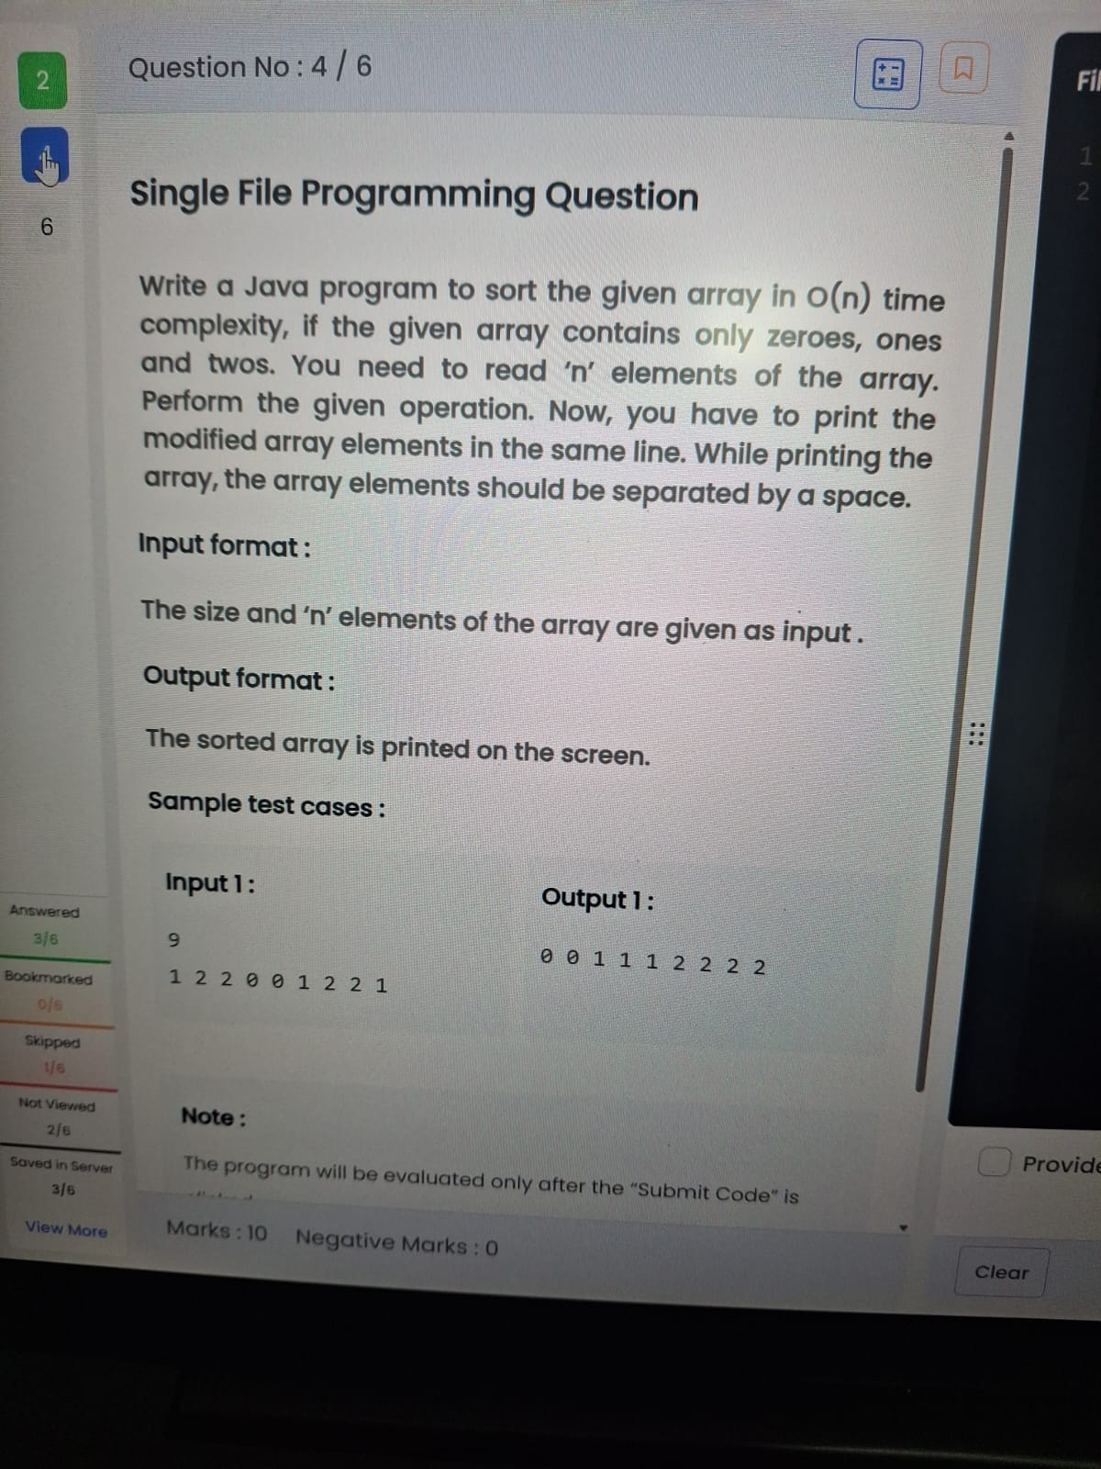

import java.util.*;

public class Main {

public static void main(String[] args) {

Scanner sc = new Scanner(System.in);

int n = sc.nextInt();

int[] a = new int[n];

for(int i=0;i<n;i++)

a[i] = sc.nextInt();

int c0=0,c1=0,c2=0;

for(int i=0;i<n;i++){

if(a[i]==0) c0++;

else if(a[i]==1) c1++;

else c2++;

}

for(int i=0;i<c0;i++) System.out.print("0 ");

for(int i=0;i<c1;i++) System.out.print("1 ");

for(int i=0;i<c2;i++) System.out.print("2 ");

}

}

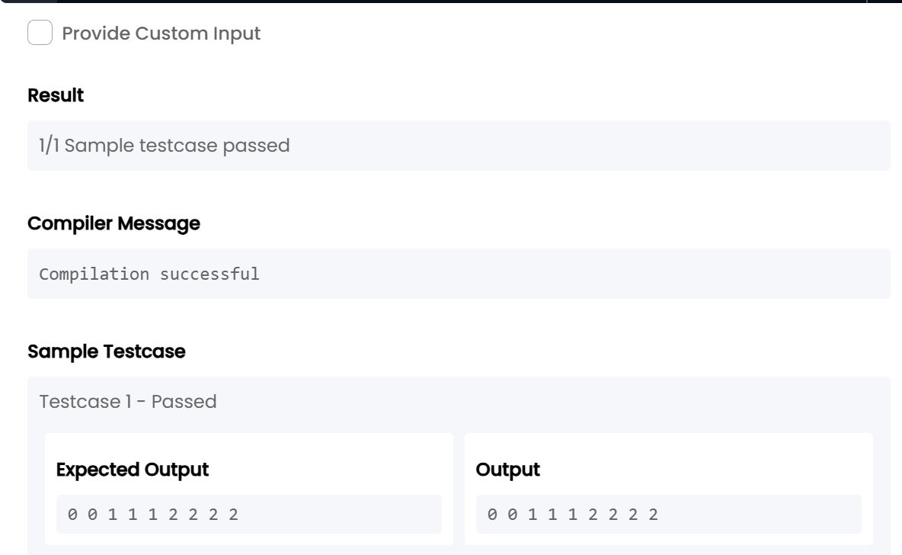

TASK21:

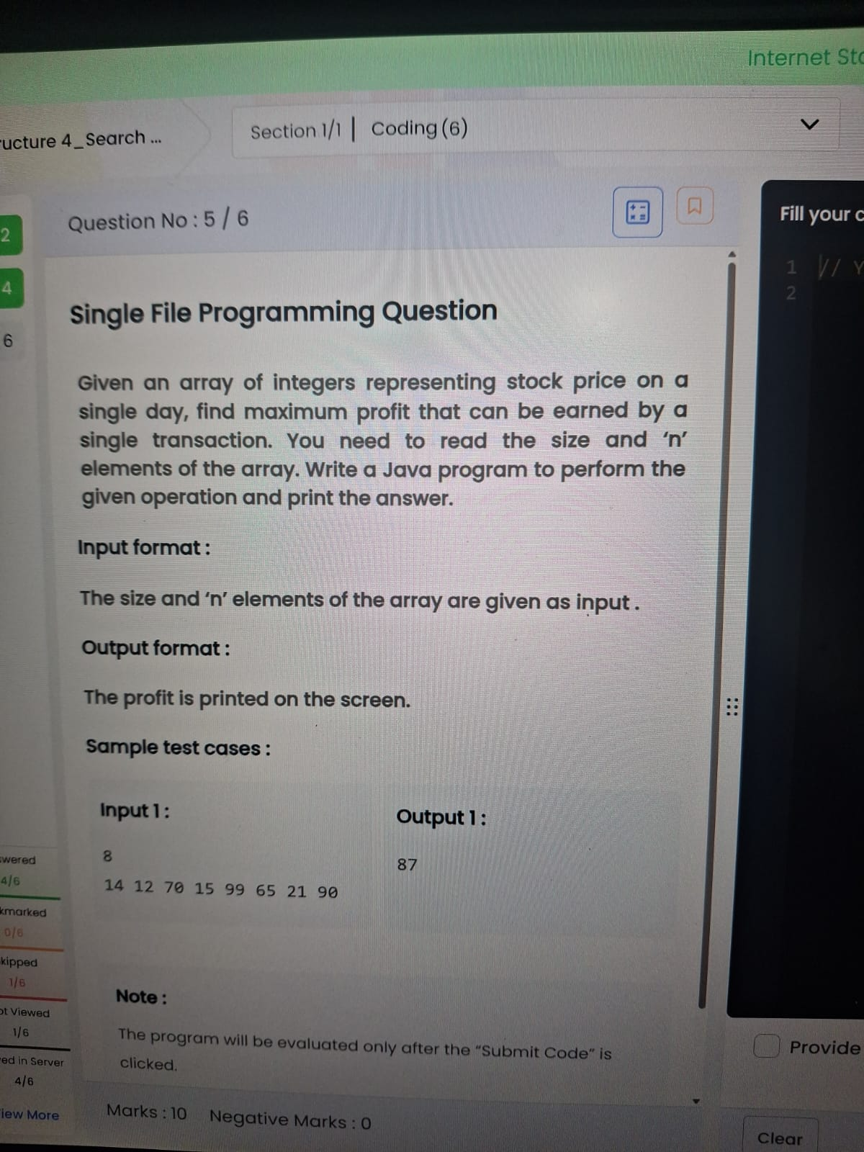

import java.util.*;

public class Main {

public static void main(String[] args) {

Scanner sc = new Scanner(System.in);

int n = sc.nextInt();

int min = Integer.MAX_VALUE, profit = 0;

for(int i = 0; i < n; i++) {

int price = sc.nextInt();

if(price < min)

min = price;

else if(price - min > profit)

profit = price - min;

}

System.out.print(profit);

}

}

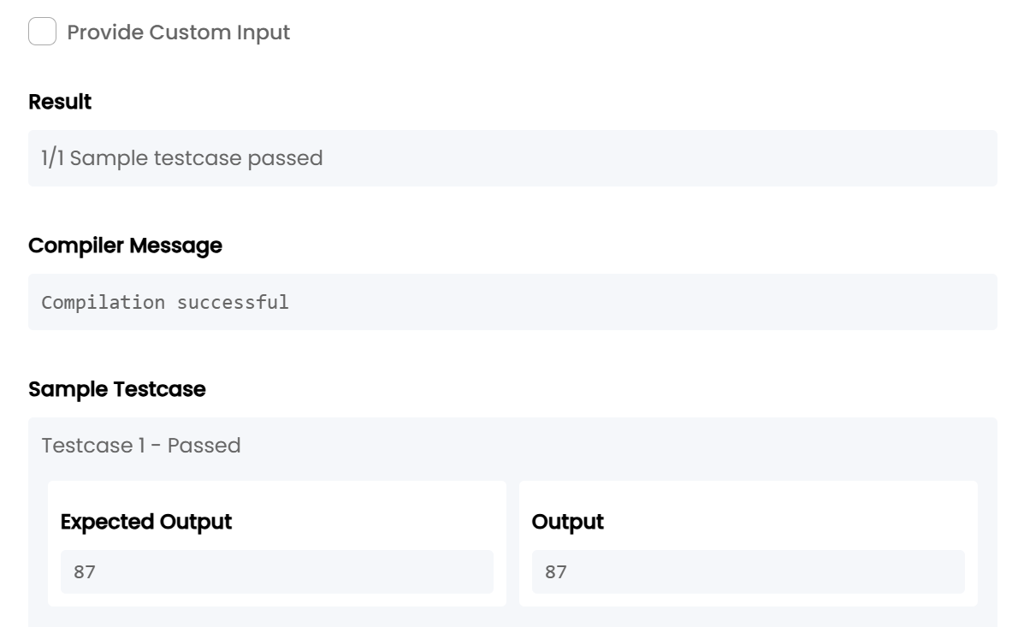

TASK22:

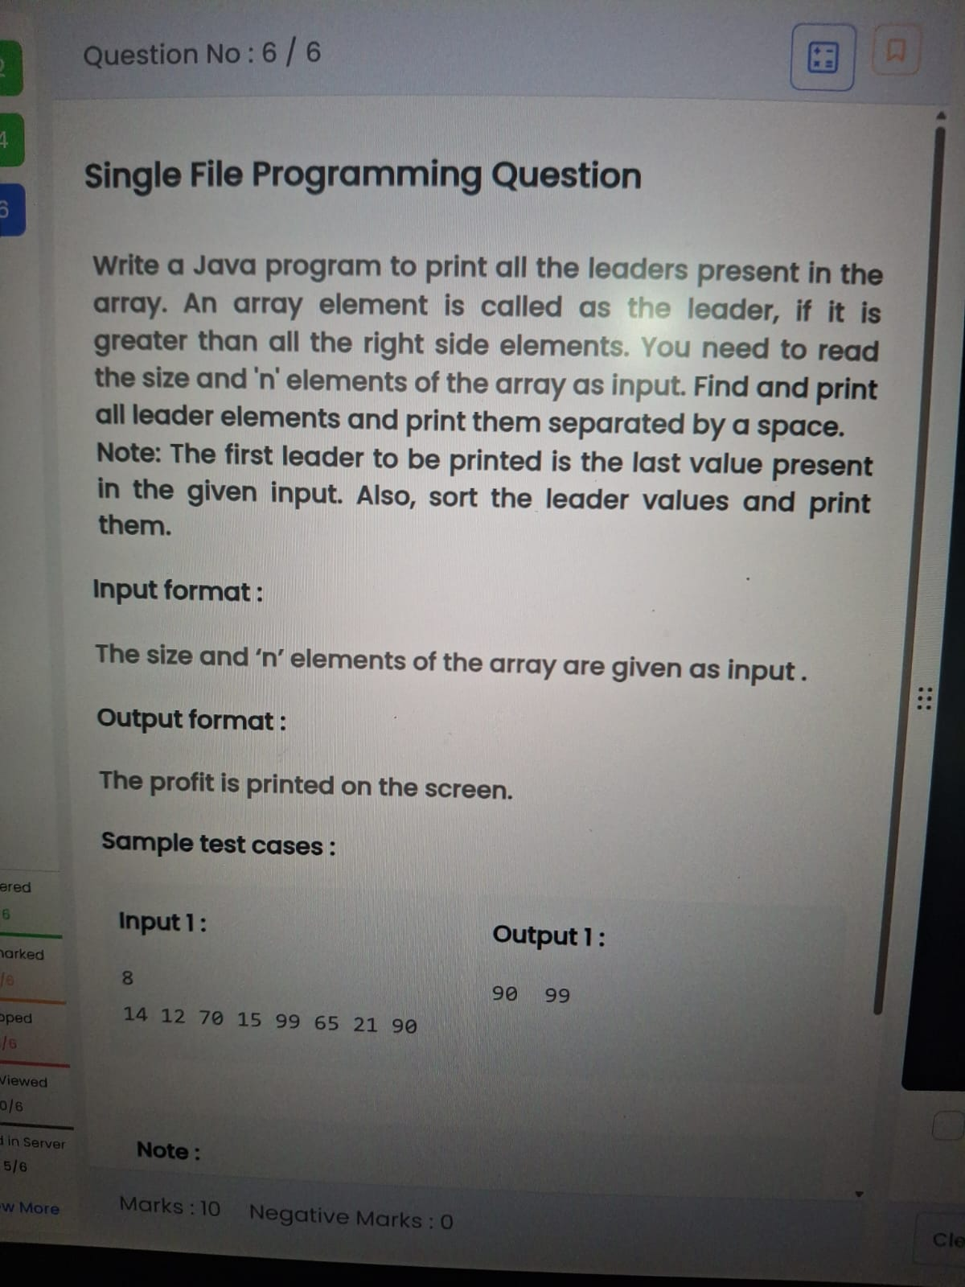

import java.util.*;

public class Main {

public static void main(String[] args) {

Scanner sc = new Scanner(System.in);

int n = sc.nextInt();

int[] a = new int[n];

for(int i=0;i<n;i++)

a[i] = sc.nextInt();

ArrayList<Integer> list = new ArrayList<>();

int max = Integer.MIN_VALUE;

for(int i=n-1;i>=0;i--){

if(a[i] > max){

list.add(a[i]);

max = a[i];

}

}

Collections.sort(list);

for(int i=0;i<list.size();i++)

System.out.print(list.get(i)+" ");

}

}

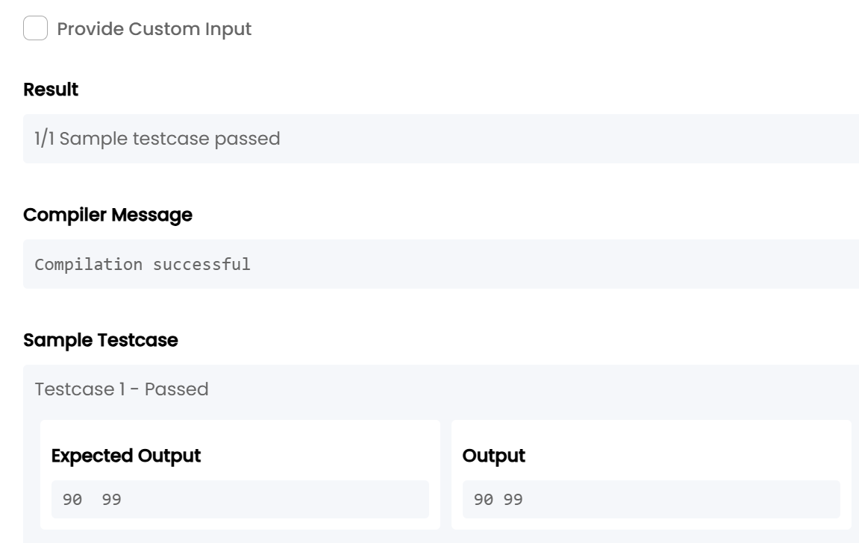

**5. Data structure 4_Search & Sorting_Chapter 3**

TASK23:

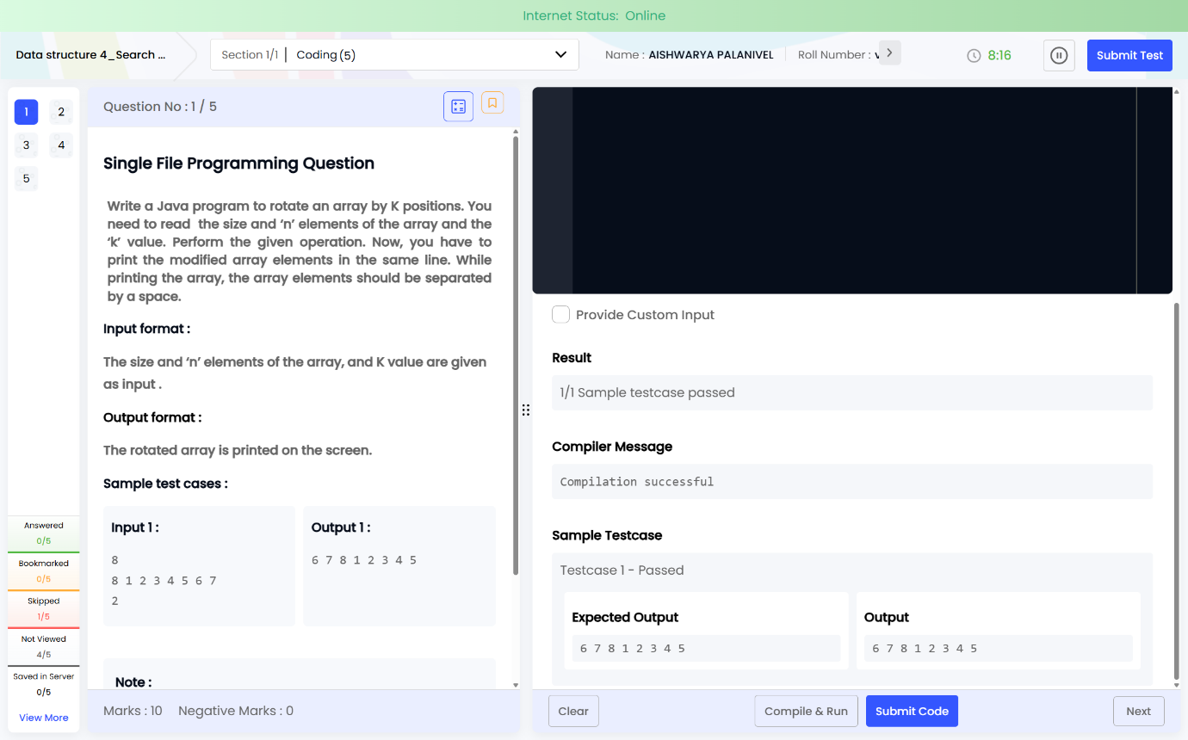

import java.util.*;

public class Main {

public static void main(String[] args) {

Scanner sc = new Scanner(System.in);

int n = sc.nextInt();

int[] a = new int[n];

for(int i=0;i<n;i++)

a[i] = sc.nextInt();

int k = sc.nextInt();

k = k % n;

for(int i=n-k;i<n;i++)

System.out.print(a[i]+" ");

for(int i=0;i<n-k;i++)

System.out.print(a[i]+" ");

}

}

TASK24:

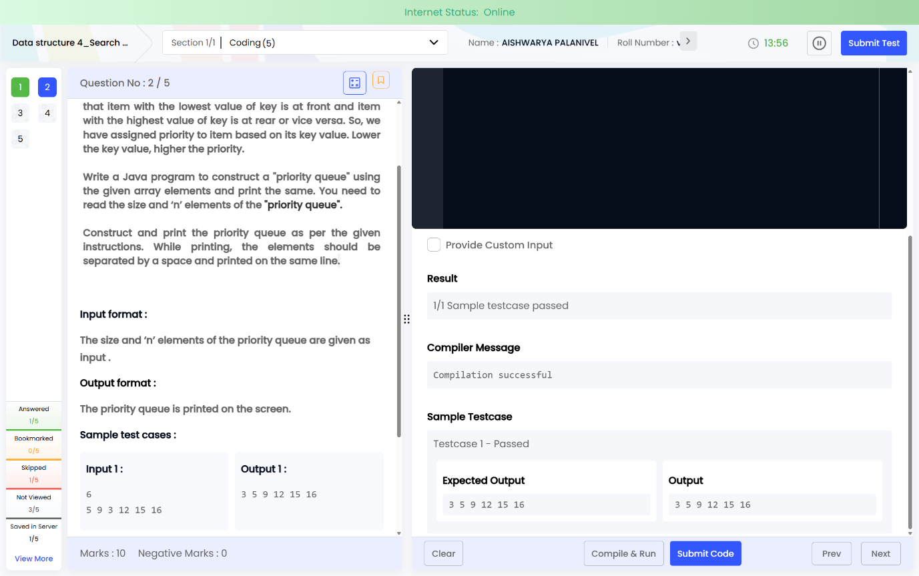

import java.util.*;

public class Main {

public static void main(String[] args) {

Scanner sc = new Scanner(System.in);

int n = sc.nextInt();

PriorityQueue<Integer> pq = new PriorityQueue<>();

for(int i=0;i<n;i++)

pq.add(sc.nextInt());

while(!pq.isEmpty())

System.out.print(pq.poll()+" ");

}

}

TASK25:

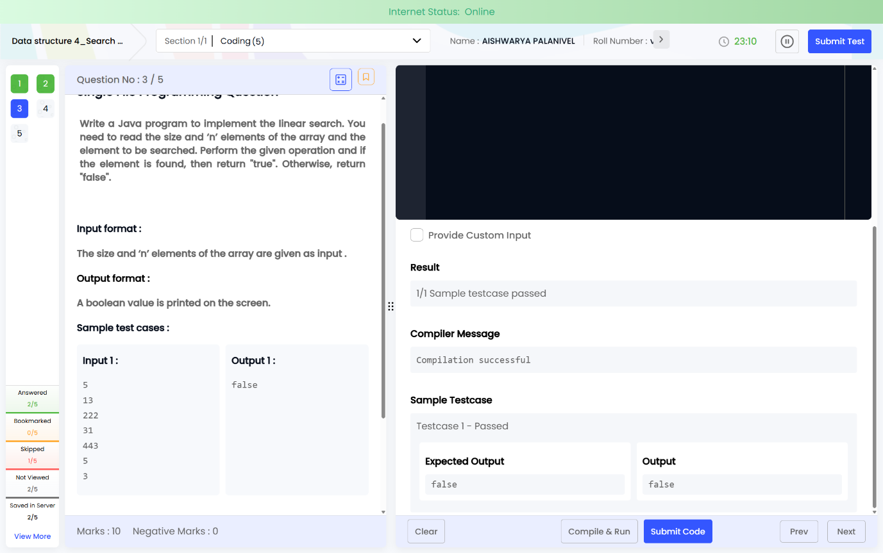

import java.util.*;

public class Main {

public static void main(String[] args) {

Scanner sc = new Scanner(System.in);

int n = sc.nextInt();

int[] a = new int[n];

for(int i=0;i<n;i++)

a[i] = sc.nextInt();

int key = sc.nextInt();

boolean found = false;

for(int i=0;i<n;i++)

if(a[i] == key)

found = true;

System.out.print(found);

}

}

TASK26:

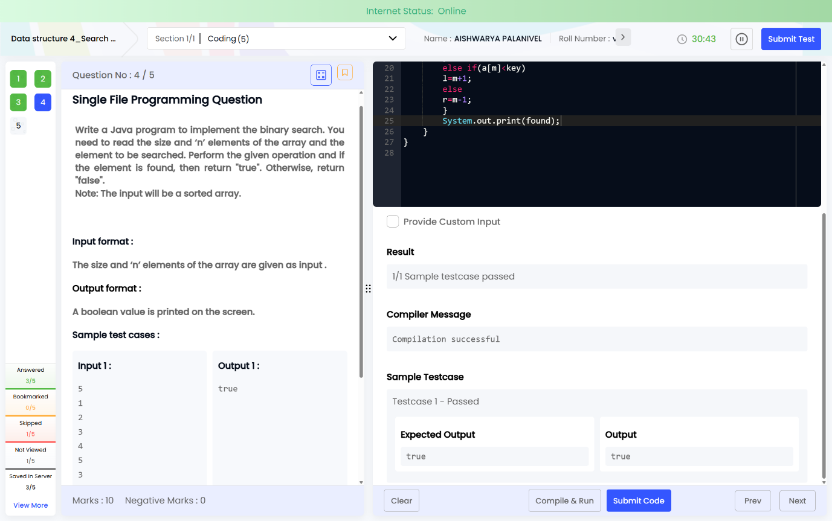

import java.util.*;

public class Main {

public static void main(String[] args) {

Scanner sc = new Scanner(System.in);

int n = sc.nextInt();

int[] a = new int[n];

for(int i=0;i<n;i++)

a[i] = sc.nextInt();

int key = sc.nextInt();

int l=0, r=n-1;

boolean found=false;

while(l<=r){

int m=(l+r)/2;

if(a[m]==key){

found=true;

break;

}

else if(a[m]<key)

l=m+1;

else

r=m-1;

}

System.out.print(found);

}

}

TASK27:

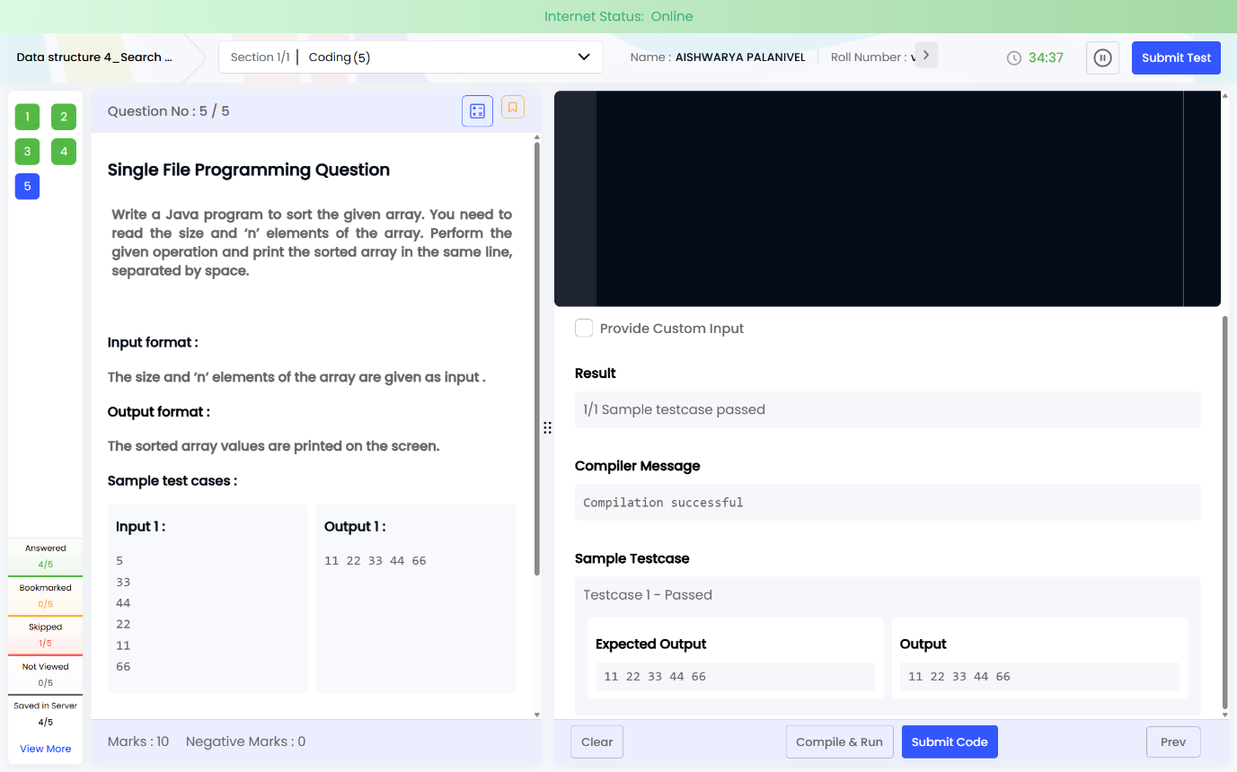

import java.util.*;

public class Main {

public static void main(String[] args) {

Scanner sc = new Scanner(System.in);

int n = sc.nextInt();

int[] a = new int[n];

for(int i=0;i<n;i++)

a[i] = sc.nextInt();

Arrays.sort(a);

for(int i=0;i<n;i++)

System.out.print(a[i] + " ");

}

}